**A PROJECT REPORT ON**



**AS PARTIAL FULLFILLMENT OF**

Bachelor of Computer Application 5th Semester

**SUBMITTED TO**

Lt. M. J. Kundaliya Arts & Commerce Mahila College

**FRONT END**

ASP .NET

**BACK END**

SQL Server - 2008

**AFFILICATED BY**

Saurashtra University

**ACADEMIC YEAR**

2024-2025

**PROJECT GUIDE**

Prof. Anil Makwana

**PROJECT HEAD**

Prof. Shamik Rathod

**PREPARED BY**

Siddhapura Bhumika V.

Rakhasiya Urvisha H.

**INDEX**

|  |  |  |
| --- | --- | --- |
| **SR.NO.** | **TOPIC NAME** | **PAGE NO.** |
| 1 | Preface | 3 |
| 2 | Acknowledgement | 4 |
| 3 | Introduction of Project | 5 |
| 4 | Requirement analysis | 6 |
| 5 | Introduction of Application | 9 |
| 6 | Feasibility Study  1)Technical Feasibility  2)Economical Feasibility  3)Operational Feasibility | 10 |
| 7 | System requirement specification  1)Hardware Requirement  2) Software Requirement | 20 |
| 8 | Flow of project | 21 |
| 9 | Normalization | 22 |
| 10 | Data Dictionary | 26 |
| 11 | Entity Relationship Diagram | 30 |
| 12 | Flow Chart | 31 |
| 13 | Data Flow Diagram | 37 |
| 14 | Use case Diagram | 49 |
| 15 | Screen Shot and Coding | 51 |
| 16 | Testing Techniques | 132 |
| 17 | Future Enhancement | 140 |
| 18 | Bibliography | 141 |

**Preface**

In 21st Century of Technology, Computer and related service is the most useful, automatic and highly speed of work. B.C.A is course in which practical aspect is important as theoretical aspect. In the present world importance of education is increasing. The project training in a student’s life is like a live experience in the industry. If we have experience then & then we get top of the level.

We are developing project in 5th Semester of B.C.A we are the student of Lt. M. J. Kundaliya Arts & Commerce Mahila College [Computer Science Department] Is Affiliated with Saurashtra University, Rajkot.

We are create this project dynamic and in this project we provide insert, update and delete operation on admin side and select at client side so user can easily show site and give feedback. In client side only feedback can add other any page can’t perform add operation .

We have gone through and study necessary information, which is collected and presented in this report. We are trying our best in this project.

We have taken almost care that are information provided in the project is true and project is in a smooth running condition and error free.

**Acknowledgement**

First of all we are sincerely thanked to Saurashtra University for giving a project as a particular subject.

We are also greatly grateful to our college **Lt. M. J. Kundaliya Arts & Commerce Mahila College [Computer Science Department], Rajkot.** We would like to thanks **Prof. Shamik Rathod (HOD)** for providing us opportunity to prepare this project.

To complete this project many persons help us. But we are specially thanked to **Prof. Anil Makwana** for guiding our project analysis and development. He helps us to conceptualize the idea of the project and helped us streamline our work by providing us with every facility required.

We also thank to whole staff members of **“Vishvakarma Techno Steel Equipments”** and specially thanked to Mr.K.K. Siddhapura (owner of Vishvakarma Techno Steel Equipments) those directly or indirectly who help to complete this project.

Not only college and guide help us but all the well wisher who gives us excellent support in during project.

Thank to all

Your Faith Fully,

Siddhapura Bhumika.

Rakhasiya Urvisha.

**Introduction of project**

We are **Siddhapura Bhumika v.** **& Rakhasiya Urvisha H.** from **BCA sem-5** .We has one subject in BCA syllabus and that is project. It is compulsory in our BCA study so, all students must prepare project on any company, shop. In project website and software preparing that two consider as project of BCA.

With that purpose to make website we visit some shop like s.s sweets, shreeji ice-cream, jeel cloth shop etc. But there we can’t get permission. So, we decide to prepare website on any company with that purpose we meet to Mr.K.K. Siddhapura (Owner of Vishvakarma Techno Steel Equipments). After that we got permission for preparing website on him company.

**Profile of project**

|  |  |
| --- | --- |
| Project Name | Vishvakarma Techno Steel Equipments |
| Front End Tool | ASP.NET |
| Back end Tool | SQL Server 2008 |
| Operating System | Windows 7 |

**Add More description as per project preliminary investigation..**

**Requirement Analysis**

* **Client side:-**
* **Home page:**

In the home page we use select operation.

* **Product:**

In the product page we use select and insert operation.

* **Gallery:**

In the Gallery page we use select operation.

* **About us:**

In this page we can use only select operation.

* **Contact us:**

In this page we can use select operation.

* **Feed back:**

In this page user can use insert operation.

* **Services:**

In this page user can use select operation.

* **Admin side:-**
* **Login page:**

In this page user can use insert operation.

* **Home page:**

In this page user can use insert, update and delete operation.

* **Product:**

In this page user can insert, update and delete operation.

* **Gallery:**

In this page user can insert, update and delete operation.

* **About us:**

In this page user can insert, update and delete operation.

* **Contact us:**

In this page user can insert, update and delete operation.

* **Feed back:**

In this page user can delete operation.

* **Services:**

In this page user can insert, update and delete operation.

Did you aware with Vishvakarma techno steel equipment product?

Yes No

Did you visit the vke-vidhi.com website?

Yes No

Did you satisfied with that website information?

Yes No

Online payment is suitable for you?

Yes No

Do you buy the products in bulk?

Yes No

Do you like to give feedback multiple times?

Yes No

Would you like that bill receipt is give you at delivery time?

Yes No

Did you see food processing machine in past?

Yes No

Did you think that machine useful to reduce people hardware?

Yes No

Would you require the videos about how the machine work and its techniques?

Yes No

85.7% people satisfied with vke-vidhi.com website.

But company owner need to update the information ,add some new data and look of website so that we decide that create new website.

64.3% are ready to multiple time feedback when 35.7%are not.

We decide that single time feedbacks are not prepher so user can give feedback multiple times because after updation in products user’s feedback can be change.

**Introduction of Platform**

* **ASP.NET:-**

Since 1995, Microsoft has been constantly working to shift its focus from windows –based platform to Internet. As a result Microsoft introduced ASP (Active Server Page) in November 1996. ASP offered the efficient of ISAPI applications along with a new level of simplicity that made it easy to understand and use.

Asp.Net defines an Application as the sum of all files pages, handles, modules and executable code that can be invoked or run in the scope of given virtual directory A Web application server. Asp.Net Provides service of allow the creation, deployment and execution of Web Application and Web Services.

However, ASP script was an interpreted script and consisted unstructured code and was difficult to debug and maintain .As the web consists of many different technologies, software integration for web development was complicated and required to understand many different technologies.

ASP.NET can be used for managing large-scale business as it is ideally suited for this purpose. This application can either be used for an intranet or can be made accessible on the internet after applying security measure so, that internet users can safely access and update information on the website.

**Write benefits and features**

* **MSSQL:-**

C #.NET to use SQL server database to store session information as identified by the Sqlconnectionstring attributes.

This is most resilient state but also the slowest by bar. To use this method of state management you will need to have a server with Sql server installed.

When setting Sql connection string you follow the same sort pattern you use with ADO.NET data access.

You will need specify data source and use id password unless you are using Sql integrated security SQL server provides multiple active result sets users define data types, managed stored procedures Sql notification and snapshots transaction isolation.

**Advantages disadvantages**

**Feasibility Study**

The feasibility study is an analysis of possible alternative solution to a problem and be commendation and the best alternative.

It includes an estimate of the level of expertise required for a project and who can provide it quantitative and qualitative assessment of other essential resources identification of critical points a general timetable and a general cost estimate.

The Feasibility study should examine three main areas:-

* Market issues.
* Technical and organizational requirement
* Financial overview

The result of three type study are used to make a decision whether to process we have project or table it.

**There are three types of feasibility study:-**

**1) Technical Feasibility**

**2) Economical Feasibility:-**

**3) Operational Feasibility**

* **Technical Feasibility:-**

In the technical feasibility the system analysis look between the requirements of the organization such as:

* Input device.
* Output device.
* Choice of processing unit.

**Operating system: Windows & Utilization**

When we implement the windows 7 utilization with the following processor usage.

* **Intel (R) core ™ i5 -6400 CPU @ 2.70 GHz**
* **Before Operating System starts:-**
* **Advanced Frequency setting**

CPU clock Ratio: Auto 2.7

CPU Frequency: 2.70 GHz

Memory Frequency: 2133 MHz

* **Advanced Memory Utilization**

Memory frequency: 2133 MHz

Profile DDR voltage: 1.20v.

* **PC Health Status**

CPU v core: 1.164v

DRAM channel: 1.236

+3.3v:3.383v

+5v:5.220v

+12v:12.240v

CPU VAXG: 0.00v

* **SMART Fan Utilization**

Temperature: 51.0’c

Fan speed: 2242 RAM

* **CPU**
* Frequency 3100.85MHz
* BCLK 100MHz
* Temperature 51.0’s
* Voltage 1.164v.
* **Memory**
* Frequency 2133.33MHz
* 4096 MB
* **Voltage**
* +5v
* +12v
* 5.220v
* 12.240v
* **Installed Memory (RAM)**
* -4GB
* **Hard disk**
* -1 TB
* **After Operating System started utilization process:-**
* **Physical Memory (MB)**

|  |  |
| --- | --- |
| Total | 3983 |
| Cached | 576 |
| Available | 858 |
| Free | 26 |

* **Kernel Memory (MB)**

|  |  |
| --- | --- |
| Paged | 223 |
| NonPaged | 90 |

* **System**

|  |  |
| --- | --- |
| Handles | 34024 |
| Threads | 1756 |
| Processes | 97 |
| Up time | 0:01:06:01 |
| Commit (MB) | 6179/7966 |

* **When Operating System Starts**

|  |  |
| --- | --- |
| CPU usage is | 9% |
| Maximum frequency | 65 |
| Disk I/O is | 1 MB/sec |
| Highest Active time is | 100% |
| Network I/O is | 61 kbps |
| Network utilization | 6% |
| Physical memory is | 58% |

* **After Operating System started Utilization process with visual Studio & Explorer devenv.exe:-**

|  |  |
| --- | --- |
| **CPU** | **DISK** |
| CPU :2 | Read :129 B/sec |
| Thread:25 | Write: 1 B/sec |
| Plateform:64bit | Total: 130 B/sec |
| Average CPU:0.03 |  |

|  |  |
| --- | --- |
| **Network** | **Memory** |
| Send: 0 B/sec | Commit: 264808 kbps |
| Receive: 37 B/sec | Working:275244 kbps |
| Total: 37 B/sec | Sharable: 134164 kbps |
|  | Private: 141028 kbps |

* **After Operating System started Utilization process with Google Chrome & Explorer Chrome.exe:-**

|  |  |
| --- | --- |
| **CPU** | **DISK** |
| CPU : 0 | Read :402 B/sec |
| Thread:13 | Write: 0 B/sec |
| Plateform:64bita | Total: 402 B/sec |
| Average CPU:0.31 |  |

|  |  |
| --- | --- |
| **Network** | **Memory** |
| Send: 30 B/sec | Commit: 47720 kbps |
| Receive: 30 B/sec | Working:57112 kbps |
| Total: 60 B/sec | Sharable: 35540 kbps |
|  | Private: 21576 kbps |

* **Intel (R) core ™ i5 -6300 CPU @ 1.86 GHz Processor**
* **System Information**
* **AMIBIOS**
* Version: 08.00.15
* Build date:01/08/14
* ID: 945N6001
* **Processor**
* Intel (R) core ™ i5 -6300 CPU @ 1.86 GHz
* Speed: 1866MHz
* Count; 1
* **System Memory**
* Size: 2040MB
* **CPU Utilization**

Module Version: 3F.15

Frequency: 1.86 GHz

FSB Speed: 1066 MHz

Cache L1: 64 KB

Cache L2: 2048 KB

Ratio Actual Value: 7

Installed Memory RAM: 2 GB

Hard disk: 250 GB

* **After Operating System started utilization process:-**
* **Physical Memory (MB)**

|  |  |
| --- | --- |
| Total | 2039 |
| Cached | 1251 |
| Available | 1040 |
| Free | 1 |

* **Kernel Memory (MB)**

|  |  |
| --- | --- |
| Paged | 172 |
| NonPaged | 18 |

* **System**

|  |  |
| --- | --- |
| Handles | 16129 |
| Threads | 732 |
| Processes | 59 |
| Up time | 0:00:06:01 |
| Commit (MB) | 1703/4078 |

* **When Operating System Starts**

|  |  |
| --- | --- |
| CPU usage is | 25% |
| Maximum frequency | 100% |
| Disk I/O is | 5 MB/sec |
| Highest Active time is | 1% |
| Network I/O is | 4 kbps |
| Network utilization | 0% |
| Physical memory is | 39% |

* **After Operating System started Utilization process with visual Studio & Explorer devenv.exe:-**

|  |  |
| --- | --- |
| **CPU** | **DISK** |
| CPU : 0 | Read :3277 |
| Thread:13 | Write: 0 |
| Plateform:64bit | Total: 2048 |
| Average CPU:0.00 |  |

|  |  |
| --- | --- |
| **Network** | **Memory** |
| Send: 0 B/sec | Commit: 105140 |
| Receive: 35 B/sec | Working:119408 |
| Total: 35 B/sec | Sharable: 45996 |
|  | Private: 73412 |

* **After Operating System started Utilization process with Google Chrome & Explorer Chrome.exe:-**

|  |  |
| --- | --- |
| **CPU** | **DISK** |
| CPU : 0 | Read : 0 |
| Thread:6 | Write: 1634 |
| Plateform:64bit | Total: 1634 |
| Average CPU:0.08 |  |

|  |  |
| --- | --- |
| **Network** | **Memory** |
| Send: 0 B/sec | Commit: 22508 |
| Receive: 36 B/sec | Working:49784 |
| Total: 36 B/sec | Sharable: 36824 |
|  | Private: 12960 |

* **Economic Feasibility:-**

Economical feasibility means that the projected benefits of the proposed system out weight the estimated cost of usually considered the total cost of ownership (TCO).

TCO indicates ongoing support and maintains costs as well as acquisition cost.

Economical feasibility determines whether the time and money are available to develop the system that includes the purchase of new equipment hardware and software.

Economical feasibility in that an included a system analysts time cost of system study ,cost of employees tome for study ,estimated cost of hardware and cost of package software or software development.

**Write all quotation details of online and offlline**

* **The costs of Hardware and Software in project are below given:-**
* Operating System (windows 7):-Rs.4,999.00
* Hard disk:- Rs.1,099.00
* RAM:- Rs.1,390.00
* Microsoft visual studio 2010:- Rs.40,688.00

5. Microsoft SQL server 2008:- Rs.16,720.00

6. Browser (Google, Mozilla Firefox):- Freeware

Total Estimate cost is = Rs.64,896.00

**Operational Feasibility:-**

Operational feasibility determines if the human resource are available to operate any system once it has been installed

This will measure how well the proposed new system solve the problem and how it system phase development .Operating feasibility also includes on analysis of how the purposed system will affect organizational structure and procedure.

It is a measure of how well the solution will work in the organization .it is a measure of how people feel about the system.

In the operational feasibility cost includes items such as page rates, Management cost raw material cost utility rate structure fixed costs etc.

Our website is secure for admin because only admin add details new features & for user client our website very easily use. And give the feedback by filling feedback form.

Our website is reliable because it can run on all three browser or other.

-Internet Explorer

-Mozilla Firefox

- Google Chrome

**For company admin login admin have to write fields user ID & PASSWORD in login form & if any problems to handle the website.**

**If company has any issue or problem with project they can tell us and after that we must try to solve the problem in issue within our capacity or limits.**

After the website completion or implementing many changes can occurs in feature because the updating is mandatory day to day.

**In this updating duration there are some errors or problems occur at that time owner of company can contact us.** We just try to solve problem and give some tutorial and some direction or key point to owner by using that keys they can easily solve that

Problems.

**System Requirement Specification**

There are two types of system requirement.

-Hardware

-Software

* **Hardware:-**
* Processor:-

8 Bit, 2 core, 1.2 GHz or higher. (intel i3 or higher)

* RAM:-

4GB for development and evaluation use or more

* Hard disk:-

100 MB or More

* **Software:-**
* Platform:-

Windows

* Operating system:-

Windows 7 profession or any

* Front End tool:-

ASP.NET

* Back end tool:-

SQL server 2008 or higher

* Editing tool:-

Microsoft visual studio web development 2010

* Browser:-

Internet Explorer or

Mozilla Firefox or

Google Chrome or

Any browser

**Flow of Project**

* **Admin side:-**

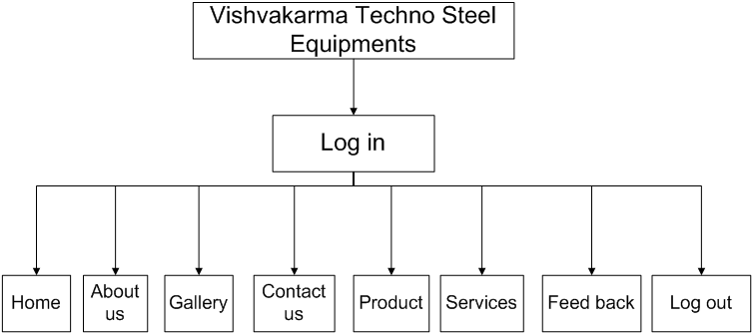

* **Client side:-**

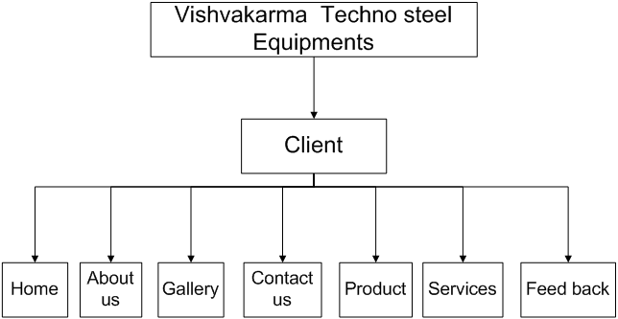

**Normalization**

Normalization is a systematic approach of decomposing table to eliminate data redundancy (repetition) and undesirable characteristics like insertion, update and deletion anomalies.

It is multi-step process that put data into tabular form, removing duplicated data from the relation table.

It is used for mainly two purposes.

* Eliminating redundant (useless) data.
* Ensuring data dependencies make sense i.e. data is logically stored.
* **UNF(Unnormalized form)**

|  |  |  |
| --- | --- | --- |
| **Category Name** | **Product Name** | **Image** |
| Kitchen(hotel) | Chula | Chula.jpg |
| Pharmacy | Pulverize | Pulverizer.jpg |
| Namkin | Dryer | Dryer.jpg |
| Dairy | Boiler machine | Boiler machine.jpg |
| Masala | Blore | Blore.jpg |
| Groh udhyog | Okhali | Okhali.jpeg |
| Namkin | Ribbon blending | Ribbon blending.jpeg |
| Kitchen (hotel) | Furniture | Furniture/table.jpg |
| Kitchen(hotel) | Food processing machines | Food processing machines.jpeg |
| Pharmacy | Ribbon blending | Ribbon blending.jpeg |
| Namkin | Dryer | Dryer.jpg |
| Dairy | Mava making machine | Mava making machine/my.jpg |
| Masala | Pulvelizer | Pulvelizer.jpg |
| Groh udhyog | Handi | Handi.jpeg |
| Namkin | Packing machine | Packing machine.jpeg |
| Kitchen (hotel) | Furniture | Furniture/chairs.jpg |

**Solution:**

We define above field in product table but same duplicate data will be create in this table so we description table in two different table.

* **1-NF(First Normalization)**

|  |  |  |  |  |  |
| --- | --- | --- | --- | --- | --- |
| **Category id** | | | **Category Name** | | **Image** |
| 1 | | | Kitchen(hotel) | | Kitchen.jpg |
| 2 | | | Pharmacy | | Pharmarcy.jpg |
| 3 | | | Namkin | | Namkin.jpg |
| 4 | | | Dairy | | Dairy.jpg |
| 5 | | | Masala | | Masala.jpg |
| 6 | | | Gruh udhyog | | Gruh.jpg |
|  | | |  | |  |
|  | | | | | |
| **Category id** | **Product id** | **Product Name** | | **Product image** | | |
| 1 | 1 | Chula | | Chula.jpg | | |
| 1 | 2 | Food processing machine | | Food processing machine.jpeg | | |
| 1 | 3 | Chimani | | Chimani.jpg | | |
| 1 | 4 | Furniture | | Furniture.jpg | | |
| 1 | 5 | Dhokla machine | | Dhoklamachine.jpg | | |
| 1 | 6 | Fresh air | | Freshair.jpg | | |
| 1 | 7 | Display counter | | Displaycounter.jpg | | |
| 1 | 8 | Food van /cart | | Foodvan.jpeg | | |
|  |  |  | |  | | |
| 2 | 1 | Ribbon blending | | Ribbonblending.jpg | | |
| 2 | 2 | Vibrated charna | | Vibratedcharna.jpg | | |
| 2 | 3 | Pulvelizer | | Pulvelizer.jpg | | |
|  |  |  | |  | | |
| 3 | 1 | Packing machine | | Packingmachine.jpg | | |
| 3 | 2 | Kela wafer machine | | Kelawafermachine.jpg | | |
| 3 | 3 | Fafda machine | | Fafdamachine.jpg | | |
| 3 | 4 | Fryer machine | | Fryermachine.jpg | | |
| 3 | 5 | Dryer machine | | Dryermachine.jpg | | |
| 3 | 6 | Ribbon blending | | Ribbonblending.jpg | | |
| 3 | 7 | Aata making machine | | Aatamakingmachine.jpg | | |
| 3 | 8 | Chips machine | | Chipsmachine.jpg | | |
| 3 | 9 | Dry fruit machine | | Dryfruitmachine.jpg | | |
| 3 | 10 | Boiler machine | | Boilermachine.jpg | | |
| 3 | 11 | Trolley & storage rage | | Trolley.jpg & storagerage.jpg | | |
|  |  |  | |  | | |
| 4 | 1 | Mava making machine | | Mavamakingmachine.jpg | | |
| 4 | 2 | Shrikhand masala making | | Shrikhandmasalamaking.jpg | | |
| 4 | 3 | Shrikhand mixing machine | | Shrikhandmixingmachine.jpg | | |
| 4 | 4 | Boiler machine | | Boilermachine.jpg | | |
| 4 | 5 | MAP(plant) | | map.jpg | | |
|  |  |  | |  | | |
| 5 | 1 | Pulvelizer(impact) | | Pulvelizer.jpg | | |
| 5 | 2 | Blore | | Blore.jpg | | |
| 5 | 3 | Conver | | Conver.jpg | | |
| 5 | 4 | Packing machine | | Packingmachine.jpg | | |
| 5 | 5 | Vibration charna | | Vibratiorcharni.jpg | | |
| 5 | 6 | Roasting machine | | Rostingmachine.jpg | | |
| 5 | 7 | Floor mill | | Floormill.jpg | | |
| 5 | 8 | Detectors magnet | | Ditecturmagnet.jpg | | |
|  |  |  | |  | | |
| 6 | 1 | Lunch-dinner set | | Dinnerset.jpg | | |
| 6 | 2 | Tray | | Tray.jpg | | |
| 6 | 3 | Okhali | | Okhali.jpg | | |
| 6 | 4 | Handi | | Handi.jpg | | |
| 6 | 5 | Dome tray | | Dometray.jpg | | |
| 6 | 6 | Aluminum top | | top.jpg | | |

**Solution:**

Here, we require a security for admin for that we think that we must provide login feasibility any admin cannot do the changes without permission and after that we must required below given tables to store that’s page and other data for website.

1. T_login

2. T_Home

3. T_Gallery

4. T_Aboutus:-

5. T_Product

6. T_contactus

7. T_services

8. T_Feedback

9. T_Category

**Data Dictionary**

In data dictionary there are 4 fields in table field name, Data type, size and description.

* **T_Login:**

Here we require a security for admin for that we think that we must provide a login facility because any admin cannot do the changes without permission.

|  |  |  |  |
| --- | --- | --- | --- |
| Field Name | Data Type | Size | Description |
| Username | Varchar | 20 | Use to store admin Username |
| Password | Nvarchar | 8 | Use to store admin password |
| Login_id | Int | 3 | Use to store specific id of different admin |

* **T_Home:-**

This table is use for the store specific description, which are show on the home page for user.

|  |  |  |  |
| --- | --- | --- | --- |
| Field Name | Data Type | Size | Description |
| H_id | Int | - | Use to store Home page id |
| Description | Varchar | - | Use to store home page description |

* **T_Gallery:-**

This Table stores the images of product and other and description for gallery page.

|  |  |  |  |
| --- | --- | --- | --- |
| Field Name | Data type | Size | Description |
| G_id | Int | - | Use to store image id |
| G_img | nvarchar | - | Use to store gallery image |
| G_imgname | Varchar | - | Use to store image name |

* **T_Aboutus:-**

Bellow table through use can get the information about Vishvakarma Techno Steel Equipments if user gets the details of Vishvakarma Techno Steel Equipments than they can easily get the details.

|  |  |  |  |
| --- | --- | --- | --- |
| Field Name | Data Type | Size | Description |
| Abtu_id | Int | 3 | Use to store about us page’s id |
| Abtu_des | Varchar | - | Use to store about us page’s description |

* **T_Product:-**

This table is required for storing the specific products details of Vishvakarma Techno Steel Equipments and product related details like name, price etc.

|  |  |  |  |
| --- | --- | --- | --- |
| Field Name | Data Type | Size | Description |
| P_id | Int | 3 | Use to store id of product |
| P_Name | Varchar | - | Use to store name of product |
| P_price | Number | - | Use to store price of product |
| P_cat | Varchar | - | Use to store specific product category |
| P_img | Nvarchar | - | Use to store image of product |
| P_des | Varchar | - | Use to store the information about product |

* **T_contactus:-**

This table is required for storing the contact details resources of Vishvakarma Techno Steel Equipments (like address, contact no)by using that user can easily contact us

|  |  |  |  |
| --- | --- | --- | --- |
| Field Name | Data Type | Size | Description |
| cu_id | Int | 3 | Use to store id of contact us page |
| cu_email | Varchar | - | Use to store email addresses of contact us page |
| cu_add | Number | - | Use to store the specific address of company |
| cu_MoNo | Nvarchar | - | Use to store mobile number of company |
| cu_map | Nvarchar | - | Use to store the image of Google map |
| cu_des | Varchar | - | Use to store the information about contact us page |

* **T_services:-**

This table is required for storing the Services details, which provided by Vishvakarma Techno Steel Equipments after purchasing the product.

|  |  |  |  |
| --- | --- | --- | --- |
| Field Name | Data Type | Size | Description |
| Ser_id | Int | 3 | Use to store services id |
| Ser_Name | Varchar | - | Use to store name of service |
| Ser_des | Varchar | - | Use to store services description |
| Ser_img | Varchar | - | Use to store service related images |

**T_Feedback:-**

This table is creating to store the feedbacks of user which they are given for our site & Vishvakarma Techno Steel Equipments.

|  |  |  |  |
| --- | --- | --- | --- |
| Field Name | Data Type | Size | Description |
| F_id | Int | 3 | Use to store feedback id |
| F_Name | Varchar | - | Use to store name of users |
| F_MoNo | numeric | - | Use to store mobile number of users |
| F_email | Varchar | - | Use to store users email address |
| F_comment | Varchar | - | Use to store users comments |

* **T_Category:-**

Below table is use to store the details about the Category of item which we use in product page.

|  |  |  |  |
| --- | --- | --- | --- |
| Field Name | Data Type | Size | Description |
| cat_id | Int | 3 | Use to store category id of product |
| cat_Name | Varchar | - | Use to store name of Category |

**Entity Relationship Diagram**

ER Diagram is composed of entity types and specifies relationships that can exist between entities.

* **System & Function**

|  |  |
| --- | --- |
| **Symbol** | **Function** |
| Start/Stop | It indicates starting point and ending point in program. |
| Input / Output | It used when an input or output operation is to be performed. |
| Decision | Diamond shape indicates that decision should be taken this is represents relations set. |
| Processing | It indicates process that should be performed by pc. |
| Connector | When program flow run into many pages to take some of the part. |
| Flow | It shows the direction of program transmitted from on e to another. |
| Ellipse | That represent attribute. |
| Line | It connecting line of strong entity set with the relationship is single. |

 

 M  1 



**Flow Chart**

* **ADMIN SIDE :-**
* **Log in**

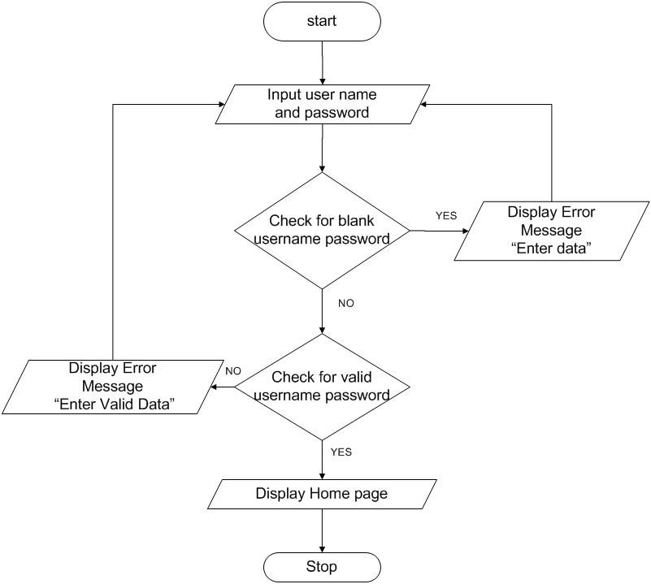

* **Feed back**

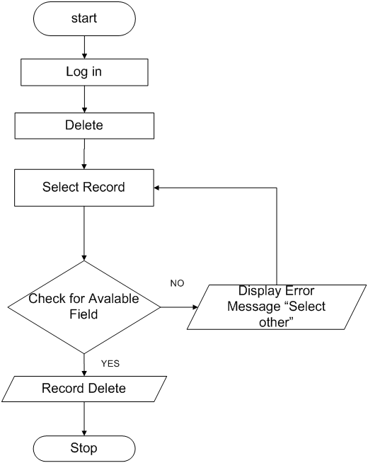

* **Home ,About us ,Gallery ,Contact us ,Product ,Services**
* 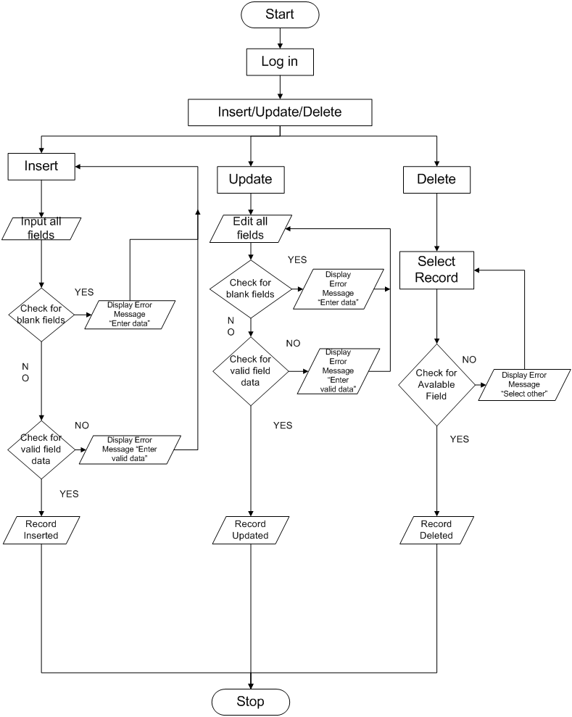
* **CLIENT SIDE :-**
* **Home ,About us ,Gallery ,Contact us ,Services**

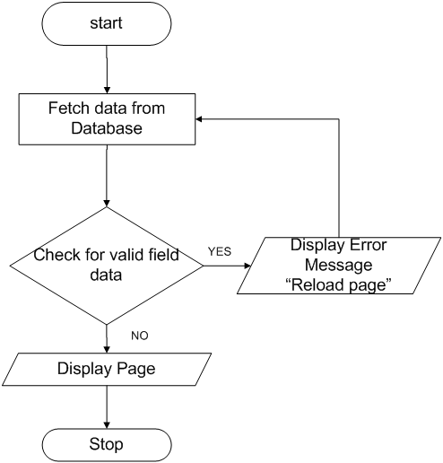

* **Feed back**

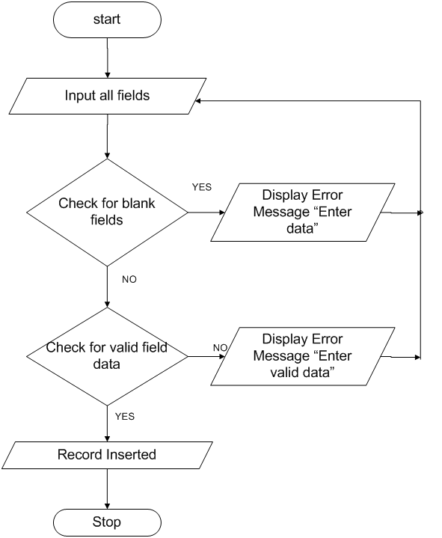

* **Product**

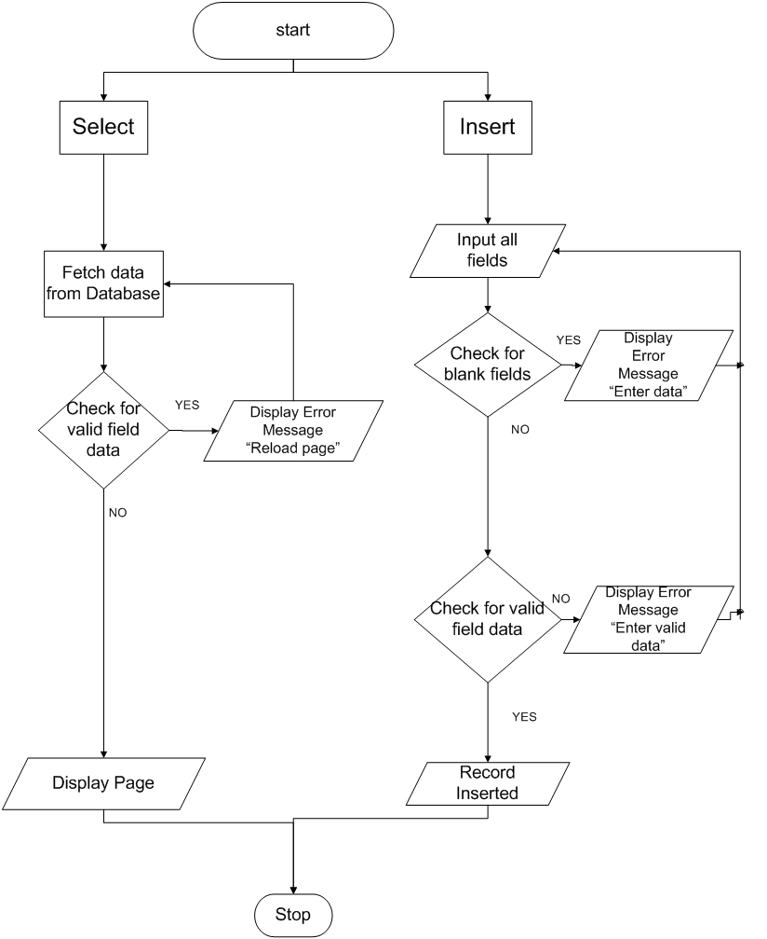

**Data Flow Diagram**

* **Admin Side:-**
* **Login**

[0- Level]

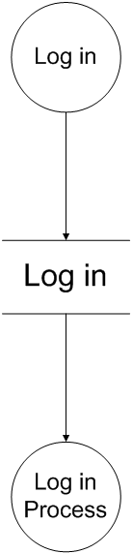

[1- Level]

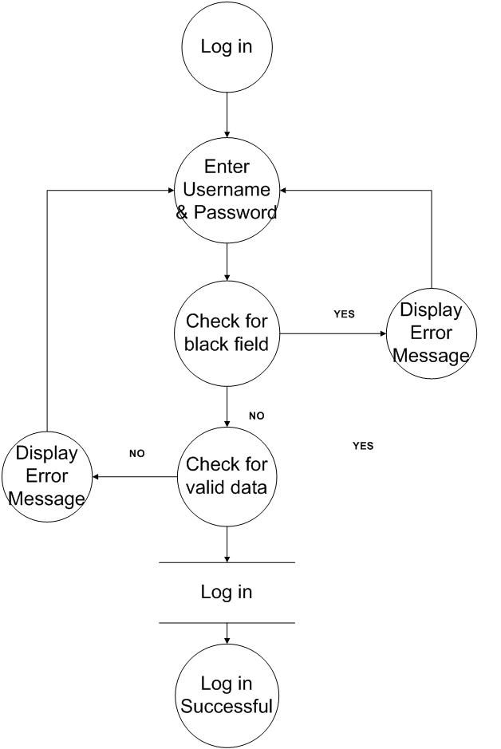

* **Home ,Product ,Gallery ,Contact us ,Services ,About us**

[0- Level]

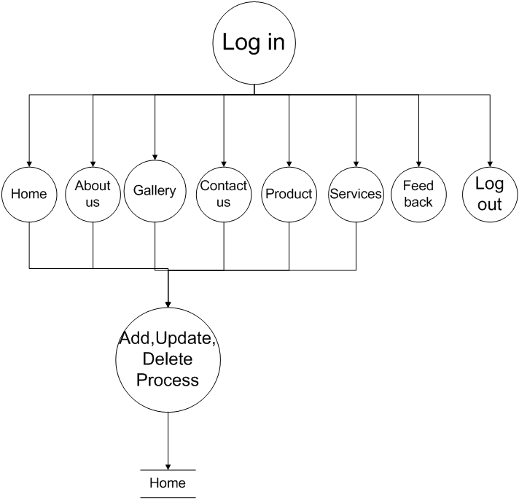

[1- Level]



* **Feed back**

[0- Level]

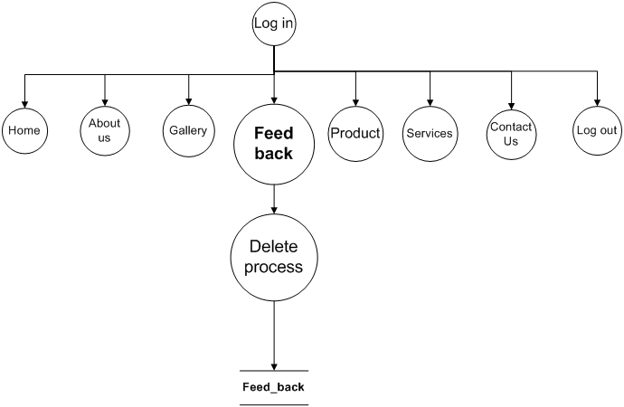

[1- Level]

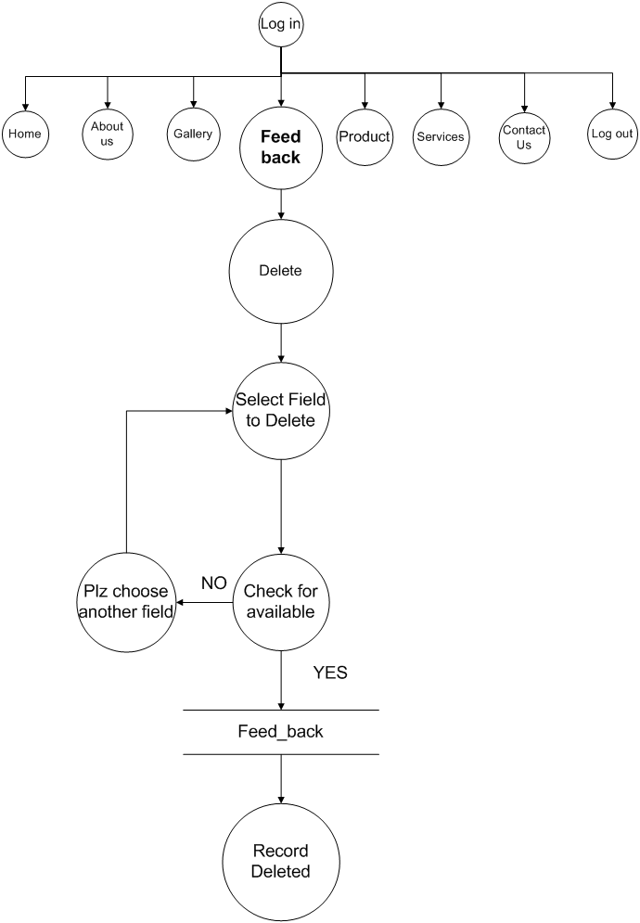

**Client Side:-**

* **Home ,Gallery ,Contact us ,Services ,About us**

[0-Level]

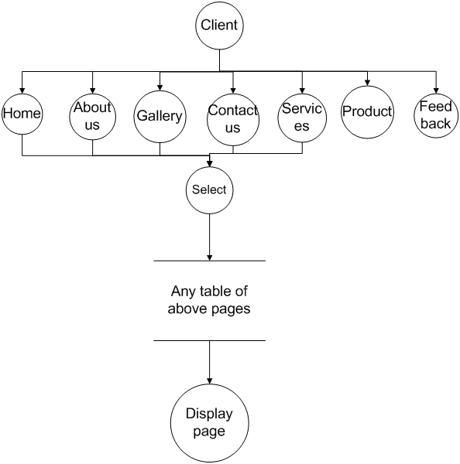

[1-Level]

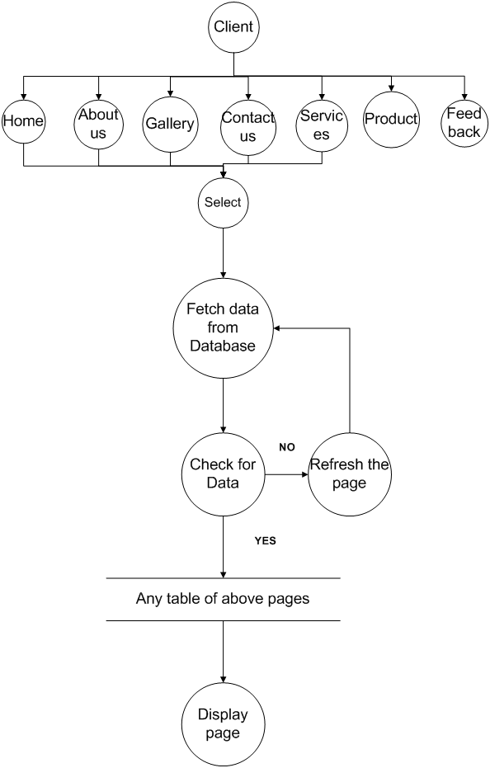

* **Feed back**

[0- Level]



[1-Level]

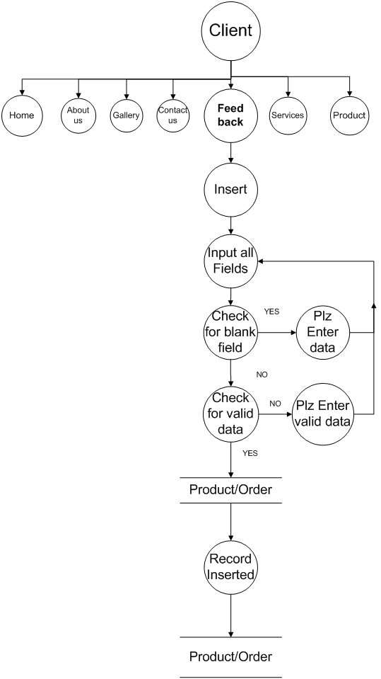

* **Product**

[0- Level]

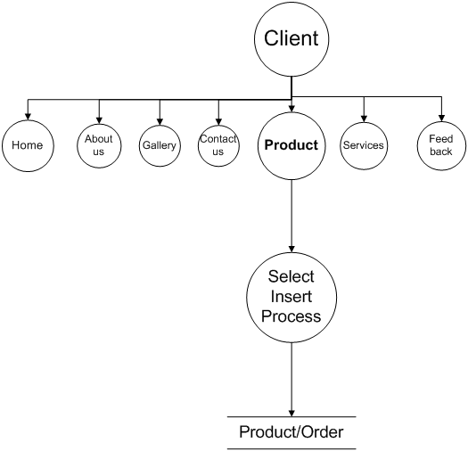

[1-Level]

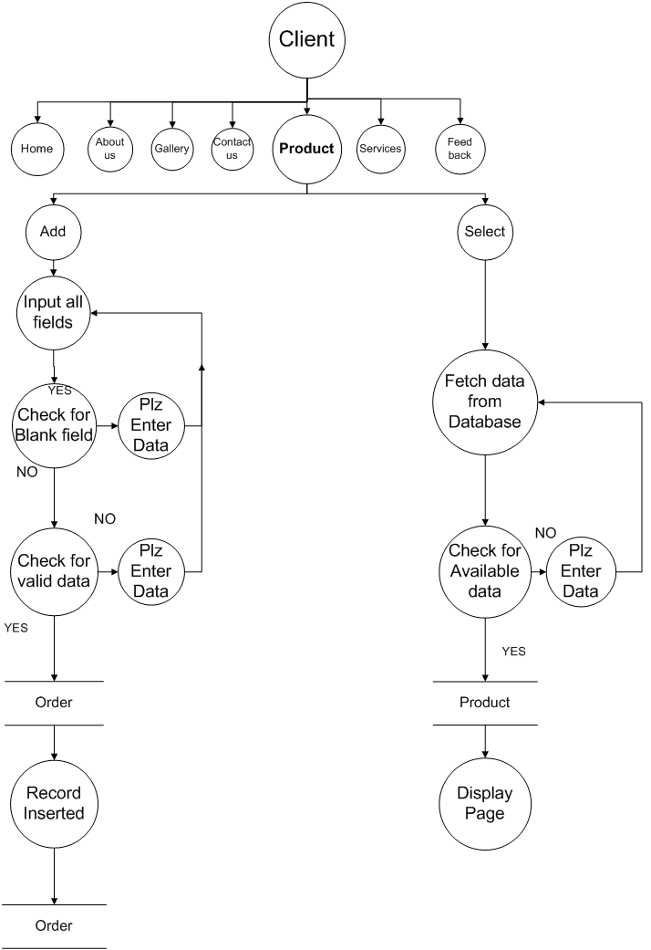

**Use case Diagram**

* **Admin Side:-**

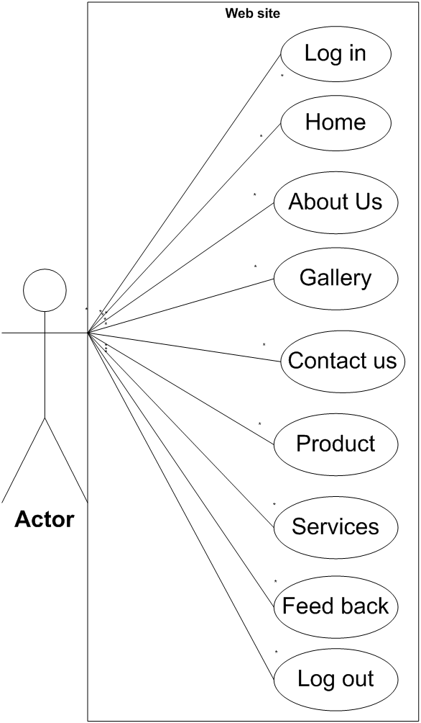

* **Client Side:-**

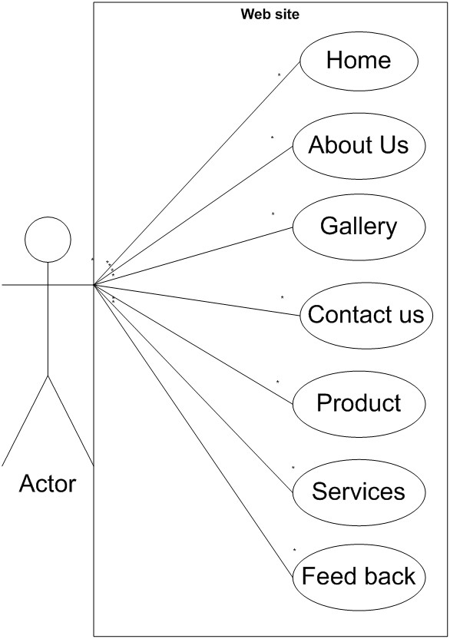

**Screen shorts and Coding**

* **Admin side**
* **login.aspx**

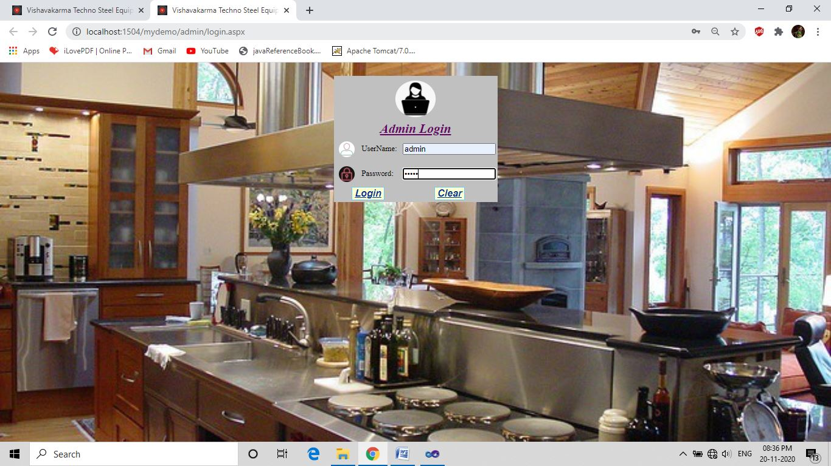

<%@ Page Language="C#" AutoEventWireup="true" CodeFile="login.aspx.cs" Inherits="admin_login" %>

<%@ OutputCache Duration="1" NoStore="true" VaryByParam=None %>

<!DOCTYPE html PUBLIC "-//W3C//DTD XHTML 1.0 Transitional//EN" "<http://www.w3.org/TR/xhtml1/DTD/xhtml1-transitional.dtd>">

<html xmlns="http://www.w3.org/1999/xhtml">

<head runat="server">

<link rel="icon" a href="~/images/url icon.jpg" />

<title> Vishavakarma Techno Steel Equipments</title>

</head>

<Style>

Body, html

{ Height: 100%;

Margin: 0; }

.zoom

{ transition: transform .2s;

padding: 10px;

border-radius: 50%; }

.zoom:hover

{ transform:scale(1.6); }

.bg

{background-image:url("../images/COMMERCIAL KITCHEN.jpg");

background-position:center;

background-repeat:no-repeat;

background-size:cover; }

.td

{ width: 100px; }

</style>

<body class="bg">

<form id="form1" runat="server" >

<div>

<center>

<table style="background-color: Silver;">

<tr >

<td colspan="3" align="center" >

<asp:Image ID="imgadmin" runat="server" ImageUrl="~/images/b4b44d3367a51b5f4cc9d35a6307b594.jpg" Height="90px" Width="100px" ImageAlign="Middle" CssClass="zoom" />

</td> </tr>

<br />

<tr >

<td colspan="3" align="center">

<asp:Label ID="btntitle" runat="server" Font-Bold="True" Font-Italic="True"

Font-Overline="False" Font-Underline="True" ForeColor="#660066"

Text="Admin Login" Font-Size="XX-Large" />

</td> </tr>

<tr> <td>

<asp:Image ID="imgunm" runat="server" ImageUrl="~/images/ADMIN.jpg" Height="40px" Width="40px" CssClass="zoom"/>

</td>

<td class="td">

<asp:Label ID="lblunm" runat="server" Text="UserName:" Font-Size="Larger"></asp:Label>

</td>

<td class="td">

<asp:TextBox ID="txtusnmn" runat="server" Font-Size="Larger"></asp:TextBox><br />

</td> </tr>

<tr> <td>

<asp:Image ID="imgpsw" runat="server" ImageUrl="~/images/93eefa3f60981fa3c15eadf00a4816c4.jpg" Height="40px" Width="40px" CssClass="zoom" />

</td>

<td class="td">

<asp:Label ID="lblpsw" runat="server" Text="Password:" Font-Size="Larger"></asp:Label>

</td>

<td class="td">

<asp:TextBox ID="txtpsw" runat="server" Font-Size="Larger" TextMode="Password"></asp:TextBox>

</td> </tr>

<br />

<tr> <td colspan="2" align="center">

<asp:Button ID="btnlogin" runat="server" Text="Login" Font-Italic="True"

Font-Bold="True" Font-Underline="True" ForeColor="#003399"

BorderColor="#66CCFF" BorderStyle="Solid" BackColor="#FFFFCC"

Font-Size="X-Large" onclick="btnlogin_Click" />

</td> <td align="center">

<asp:Button ID="btnclear" runat="server" Text="Clear" Font-Italic="True"

Font-Bold="True" Font-Underline="True" ForeColor="#003399"

BorderColor="#66CCFF" BorderStyle="Solid" BackColor="#FFFFCC"

Font-Size="X-Large" onclick="btnclear_Click" />

</td> </tr>

<tr>

<td colspan="3" align="center">

<asp:Label ID="lblmsg" runat="server" Text="" Font-Bold="True"

Font-Italic="True" Font-Size="Larger" Font-Names="Arial" ForeColor="#FF3300"></asp:Label>

</td>

</tr>

</table>

</center>

</div>

</form>

</body>

</html>

* **login.aspx.cs**

using System;

using System.Collections.Generic;

using System.Linq;

using System.Web;

using System.Web.UI;

using System.Web.UI.WebControls;

using System.Data;

using System.Data.SqlClient;

public partial class admin_login : System.Web.UI.Page

{ SqlConnection con = new SqlConnection("Data Source=.\\SQLEXPRESS;AttachDbFilename=|DataDirectory|\\Databaseproject.mdf;Integrated Security=True;User Instance=True");

protected void Page_Load(object sender, EventArgs e)

{ txtusnmn.Focus();

}

protected void btnlogin_Click(object sender, EventArgs e)

{ con.Open();

string str = "select * from T_login where username=@username and password=@password";

SqlCommand cmd = new SqlCommand(str, con);

cmd.Parameters.AddWithValue("@username", txtusnmn.Text);

cmd.Parameters.AddWithValue("@password",txtpsw.Text);

int ans = cmd.ExecuteNonQuery();

SqlDataAdapter da = new SqlDataAdapter(cmd);

DataTable dt = new DataTable();

da.Fill(dt);

con.Close();

if (dt.Rows.Count>0)

{ Session["user"] = txtusnmn.Text;

Response.Redirect("~/admin/Homeadmin.aspx");

}

else

{ lblmsg.Text = "Login failed....."; }

}

protected void btnclear_Click(object sender, EventArgs e)

{ Response.Redirect("~/admin/login.aspx");

}}

* **MasterPageadmin.master**

<%@ Master Language="C#" AutoEventWireup="true" CodeFile="MasterPageadmin.master.cs" Inherits="admin_MasterPageadmin" %>

<!DOCTYPE html PUBLIC "-//W3C//DTD XHTML 1.0 Transitional//EN" "<http://www.w3.org/TR/xhtml1/DTD/xhtml1-transitional.dtd>">

<html xmlns="http://www.w3.org/1999/xhtml">

<head runat="server">

<link rel="icon" a href="~/images/url icon.jpg" />

<title> Vishvakarma Techno Steel Equipments</title>

<asp:ContentPlaceHolder id="head" runat="server">

</asp:ContentPlaceHolder>

</head>

<body>

<form id="form1" runat="server">

<center> <style>

.link

{ background-color: Gray;

border: solid;

border-color:Gray; }

.link:hover

{ background-color: transparent ;

text-transform: uppercase;

color: Blue; }

.link:visited

{ background-color:Gray ;

text-transform: uppercase;

color: Maroon; }

.link:active

{ background-color: transparent ;

text-transform: uppercase;

color: Green ;

}

.bg{ background-image:url("../images/VIEW.jpg");

background-position:center;

background-repeat:no-repeat;

background-size:cover;

}

</style>

<div >

<asp:Image ID="Image2" runat="server" ImageUrl="~/images/images (37).jpeg" Height="150px" Width="100px"/>

<asp:Image ID="headerimg" runat="server" ImageUrl="~/images/header image.jpg" Height="200px" Width="900px"/>&nbsp;&nbsp;&nbsp;&nbsp;&nbsp;&nbsp;&nbsp;&nbsp;&nbsp;&nbsp;&nbsp;&nbsp;&nbsp;&nbsp;&nbsp;&nbsp;&nbsp;&nbsp;&nbsp; <asp:Image ID="Image1" runat="server" ImageUrl="~/images/images (5).jpeg" Height="200px" Width="150px"/>

<asp:Panel ID="header" runat="server" BackColor="#FFFFCC" Height="30px">

<asp:HyperLink ID="hyperhome" runat="server" NavigateUrl="~/admin/Homeadmin.aspx" CssClass="link">Home</asp:HyperLink>

<asp:HyperLink ID="HyperAboutus" runat="server" NavigateUrl="~/admin/aboutus.aspx" CssClass="link">About us</asp:HyperLink>

<asp:HyperLink ID="HyperGallery" runat="server" NavigateUrl="~/admin/Galleryadmin.aspx" CssClass="link">Gallery</asp:HyperLink>

<asp:HyperLink ID="HyperProduct" runat="server" NavigateUrl="~/admin/Productadmin.aspx" CssClass="link">Product</asp:HyperLink>

<asp:HyperLink ID="HyperContactus" runat="server" NavigateUrl="~/admin/contactusadmin.aspx" CssClass="link">Contact us</asp:HyperLink>

<asp:HyperLink ID="Hyperservices" runat="server" NavigateUrl="~/admin/servicesadmin.aspx" CssClass="link" >Services</asp:HyperLink>

<asp:HyperLink ID="HyperFeedback" runat="server" NavigateUrl="~/admin/feedbackadmin.aspx" CssClass="link" >Feedback</asp:HyperLink>

<asp:HyperLink ID="Hyperlogout" runat="server" NavigateUrl="~/admin/logout.aspx" CssClass="link">Log out</asp:HyperLink>

</asp:PaneL>

</div>

<asp:ContentPlaceHolder id="ContentPlaceHolder1" runat="server">

</asp:ContentPlaceHolder>

<div>

<asp:Panel ID="footer" runat="server" BackColor="#FFFFCC" Height="50px">

<h2> Devloped By: Bhumika Siddhapura & Urvisha Rakhasiya </h2>

<table height="100px" width="80%" >

<tr>

<td height="100px" width="100px">

<marquee>

<asp:Image ID="mstImage1" runat="server" ImageUrl="~/images/3 STAGE TROLLY.jpg" Height="100px" width="100px"/>

<asp:Image ID="mstImage2" runat="server" ImageUrl="~/images/AATA MAKER.jpg" Height="100px" width="100px"/>

<asp:Image ID="mstImage3" runat="server" ImageUrl="~/images/DISPLAY COUNTER.jpg" Height="100px" width="100px"/>

<asp:Image ID="mstImage4" runat="server" ImageUrl="~/images/FOODCART.jpg" Height="100px" width="100px"/>

<asp:Image ID="mstImage5" runat="server" ImageUrl="~/images/FOODSERVTABLE.jpg" Height="100px" width="100px"/>

<asp:Image ID="mstImage6" runat="server" ImageUrl="~/images/FOODVAN.jpg" Height="100px" width="100px"/>

<asp:Image ID="mstImage7" runat="server" ImageUrl="~/images/STOVE WITH TABLE.jpg" Height="100px" width="100px"/>

</marquee>

</td>

<td text-align="center">

<h3> Manufacture & Exporter of kitchen /pharmaceutical equipment & Food processing Machines</h3>

</td> </tr>

</table>

</asp:Panel>

</div>

</center>

</form>

</body>

</html>

* **MasterPageadmin.master.cs**

using System;

using System.Collections.Generic;

using System.Linq;

using System.Web;

using System.Web.UI;

using System.Web.UI.WebControls;

public partial class admin_MasterPageadmin : System.Web.UI.MasterPage

{ protected void Page_Load(object sender, EventArgs e)

{ if (!IsPostBack)

{

if (Session["user"] == null)

Response.Redirect("~/admin/login.aspx");

Response.AddHeader("cache-control","no-cache,no-store,max-age=0,mus-revalidate");

Response.AddHeader("log","no-cache");

}

}

}

* **Homeadmin.aspx**

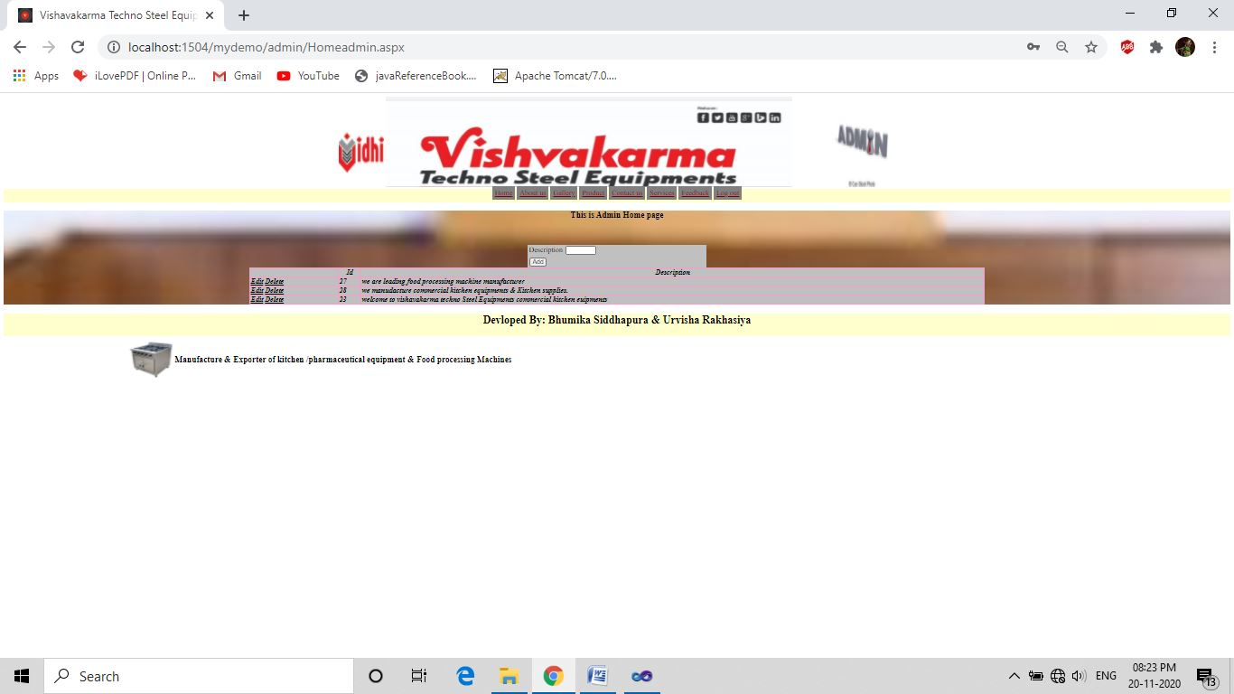

<%@ Page Title="" Language="C#" MasterPageFile="~/admin/MasterPageadmin.master" AutoEventWireup="true" CodeFile="Homeadmin.aspx.cs" Inherits="admin_Homeadmin" %>

<%@ OutputCache Duration=1 NoStore="true" VaryByParam=none %>

<asp:Content ID="Content1" ContentPlaceHolderID="head" Runat="Server">

<style type="text/css">

.style1

{ width: 61px; }

.mydiv

{ border: 5px outside Blue;

border-color: Blue;

text-align:center;

background-color:Gray;

background-image:url("../images/BACKGROUND IMAGE.jpg");

background-position:center;

background-repeat:no-repeat;

background-size:cover; }

.table

{ background-color: Silver; }

</style>

</asp:Content>

<asp:Content ID="Content2" ContentPlaceHolderID="ContentPlaceHolder1" Runat="Server">

<div class="mydiv">

<center>

<h3>This is Admin Home page</h3><br />

<table class="table">

<tr>

<td><asp:Label ID="lblhomedescription" runat="server" Text="Description"> </asp:Label></td>

<td><asp:TextBox ID="txthomedescription" runat="server" class="style1"

ValidationGroup="grphomeadd" ></asp:TextBox>

<asp:RequiredFieldValidator ID="RequiredFieldValidator1" runat="server"

ErrorMessage="Descriptipntion is complasory to add"

ControlToValidate="txthomedescription" ValidationGroup="grphomeadd"></asp:RequiredFieldValidator></td>

</tr><br />

<tr><td colspan="2"><asp:Label ID="lblmsg" runat="server" Text=""></asp:Label></td></tr>

<tr>

<td colspan="2">

<asp:Button ID="btnadd" runat="server" Text="Add" onclick="btnadd_Click"

ValidationGroup="grphomeadd" /></td>

</table>

<asp:GridView ID="GridView1" runat="server" AutoGenerateColumns="False"

AutoGenerateDeleteButton="True" AutoGenerateEditButton="True"

DataSourceID="SqlDataSource1" BackColor="Silver"

BorderColor="#FF99CC" BorderStyle="Solid" BorderWidth="2PX" CellSpacing="1"

ClientIDMode="Inherit" FooterStyle-ForeColor="Black" ForeColor="Black"

Font-Underline="False" Font-Bold="True" Font-Italic="True" Height="60%"

Width="60%" DataKeyNames="H_id">

<Columns>

<asp:BoundField DataField="H_id" HeaderText="Id" InsertVisible="False"

ReadOnly="True" SortExpression="H_id" />

<asp:BoundField DataField="Description" HeaderText="Description"

SortExpression="Description" />

</Columns>

</asp:GridView>

<asp:SqlDataSource ID="SqlDataSource1" runat="server"

ConnectionString="Data Source=.\SQLEXPRESS;AttachDbFilename=|DataDirectory|\Databaseproject.mdf;Integrated Security=True;User Instance=True"

DeleteCommand="delete from T_Home where H_id=@H_id;"

ProviderName="System.Data.SqlClient" SelectCommand="SELECT * FROM [T_Home]"

UpdateCommand="update T_Home set Description=@Description where H_id=@H_id;">

<DeleteParameters>

<asp:ControlParameter ControlID="GridView1" Name="H_id"

PropertyName="SelectedValue" />

</DeleteParameters>

<UpdateParameters>

<asp:ControlParameter ControlID="GridView1" Name="Description"

PropertyName="SelectedValue" />

</UpdateParameters>

</asp:SqlDataSource>

</center>

</div>

</asp:Content>

* **Homeadmin.aspx.cs**

using System;

using System.Collections.Generic;

using System.Linq;

using System.Web;

using System.Web.UI;

using System.Web.UI.WebControls;

using System.Data.SqlClient;

public partial class admin_Homeadmin : System.Web.UI.Page

{ protected void Page_Load(object sender, EventArgs e)

{ }

protected void btnadd_Click(object sender, EventArgs e)

{ string constr = "DataSource=.\\SQLEXPRESS;AttachDbFilename=|DataDirectory|\\Databaseproject.mdf;Integrated Security=True;User Instance=True";

SqlConnection con = new SqlConnection(constr);

con.Open();

string str = "insert into T_Home values(@Description)";

SqlCommand cmd = new SqlCommand(str, con);

cmd.Parameters.AddWithValue("@Description", txthomedescription.Text);

int ans1 = cmd.ExecuteNonQuery();

if (ans1 > 0)

{ lblmsg.Text = "record added...." }

else

{ lblmsg.Text = "errorr occurr........."; }

Response.Redirect("Homeadmin.aspx");

}

}

* **aboutus.aspx**

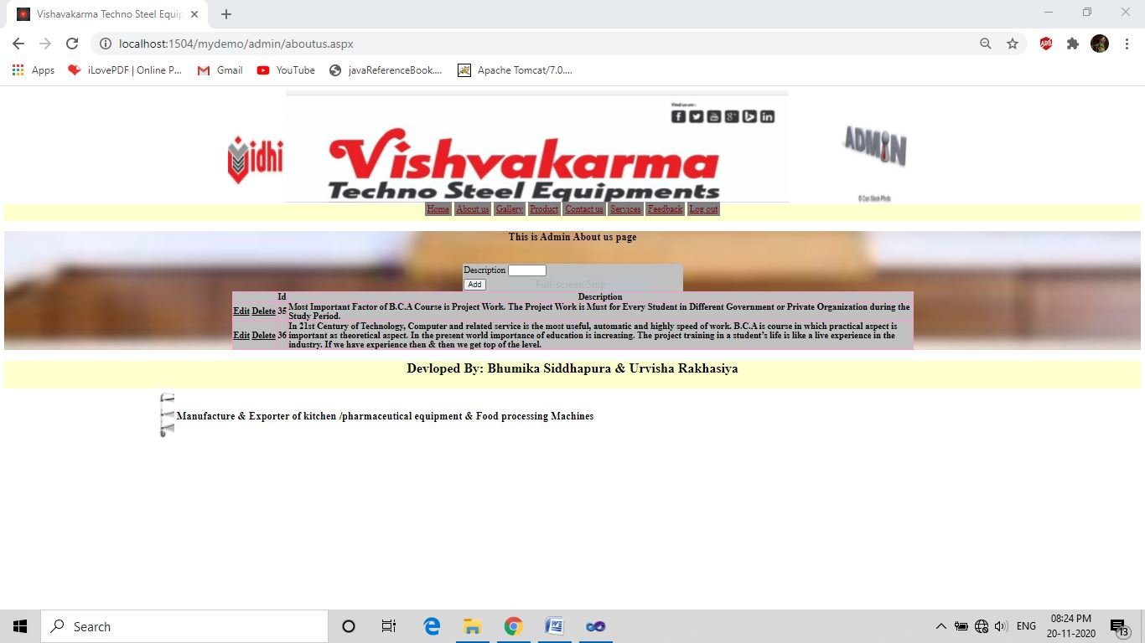

<%@ Page Title="" Language="C#" MasterPageFile="~/admin/MasterPageadmin.master" AutoEventWireup="true" CodeFile="aboutus.aspx.cs" Inherits="admin_aboutus" %>

<%@ OutputCache Duration=1 NoStore="true" VaryByParam=none%>

<asp:Content ID="Content1" ContentPlaceHolderID="head" Runat="Server">

<style type="text/css">

.style1

{

width: 61px;

}

.mydiv

{ border: 5px outside Blue;

border-color: Blue;

text-align:center;

background-color:Gray;

background-image:url("../images/BACKGROUND IMAGE.jpg");

background-position:center;

background-repeat:no-repeat;

background-size:cover;

}

.table

{ background-color: Silver;

}

</style>

</asp:Content>

<asp:Content ID="Content2" ContentPlaceHolderID="ContentPlaceHolder1" Runat="Server">

<div class="mydiv">

<center>

<h3>This is Admin About us page</h3><br />

<table class="table">

<tr>

<td><asp:Label ID="lblabtdescription" runat="server" Text="Description"> </asp:Label></td>

<td><asp:TextBox ID="txtabtdescription" runat="server" class="style1"

ValidationGroup="grpaboutusadd" ></asp:TextBox>

<asp:RequiredFieldValidator ID="RequiredFieldValidator1" runat="server"

ErrorMessage="Descriptipntion is complasory to add"

ControlToValidate="txtabtdescription" ValidationGroup="grpaboutusadd"></asp:RequiredFieldValidator>

</td>

</tr>

<tr><td colspan="2"><asp:Label ID="lblmsg" runat="server" Text=""></asp:Label></td></tr>

<tr>

<td colspan="2">

<asp:Button ID="btnadd" runat="server" Text="Add" onclick="btnadd_Click"

ValidationGroup="grpaboutusadd" /></td>

</tr>

</table >

<asp:GridView ID="GridView1" runat="server" AutoGenerateColumns="False"

AutoGenerateDeleteButton="True" AutoGenerateEditButton="True"

DataSourceID="SqlDataSource1" DataKeyNames="Abtu_id" BackColor="Silver"

BorderColor="#FF99CC" BorderStyle="Solid" BorderWidth="2PX" CellSpacing="1"

ClientIDMode="Inherit" FooterStyle-ForeColor="Black" ForeColor="Black"

Font-Underline="False" Font-Bold="True" Font-Italic="True" Height="60%"

Width="60%" >

<Columns>

<asp:BoundField DataField="Abtu_id" HeaderText="Id" InsertVisible="False"

ReadOnly="True" SortExpression="Abtu_id" />

<asp:BoundField DataField="Abtu_des" HeaderText="Description"

SortExpression="Abtu_des" />

</Columns>

</asp:GridView>

<asp:SqlDataSource ID="SqlDataSource1" runat="server"

ConnectionString="Data Source=.\SQLEXPRESS;AttachDbFilename=|DataDirectory|\Databaseproject.mdf;Integrated Security=True;User Instance=True"

DeleteCommand="delete from T_Aboutus where Abtu_id=@Abtu_id;"

ProviderName="System.Data.SqlClient" SelectCommand="SELECT * FROM [T_Aboutus]"

UpdateCommand="update T_Aboutus set Abtu_des=@Abtu_des where Abtu_id=@Abtu_id;">

<DeleteParameters>

<asp:ControlParameter ControlID="GridView1" Name="Abtu_id"

PropertyName="SelectedValue" />

</DeleteParameters>

<UpdateParameters>

<asp:ControlParameter ControlID="GridView1" Name="Abtu_des"

PropertyName="SelectedValue" />

<asp:ControlParameter ControlID="GridView1" Name="Abtu_id"

PropertyName="SelectedValue" />

</UpdateParameters>

</asp:SqlDataSource>

</center>

</div>

</asp:Content>

* **aboutus.aspx.cs**

using System;

using System.Collections.Generic;

using System.Linq;

using System.Web;

using System.Web.UI;

using System.Web.UI.WebControls;

using System.Data.SqlClient;

public partial class admin_aboutus : System.Web.UI.Page

{ protected void Page_Load(object sender, EventArgs e)

{

}

protected void btnadd_Click(object sender, EventArgs e)

{ string constr = "Data Source=.\\SQLEXPRESS;AttachDbFilename=|DataDirectory|\\Databaseproject.mdf;Integrated Security=True;User Instance=True";

SqlConnection con = new SqlConnection(constr);

con.Open();

string str = "insert into T_Aboutus values(@Abtu_des)";

SqlCommand cmd = new SqlCommand(str, con);

cmd.Parameters.AddWithValue("@Abtu_des", txtabtdescription.Text);

int ans = cmd.ExecuteNonQuery();

if (ans > 0)

{ lblmsg.Text = "record added...."; }

else

{ lblmsg.Text = "errorr occurr........."; }

Response.Redirect("aboutus.aspx");

}

}

* **Galleryadmin.aspx**

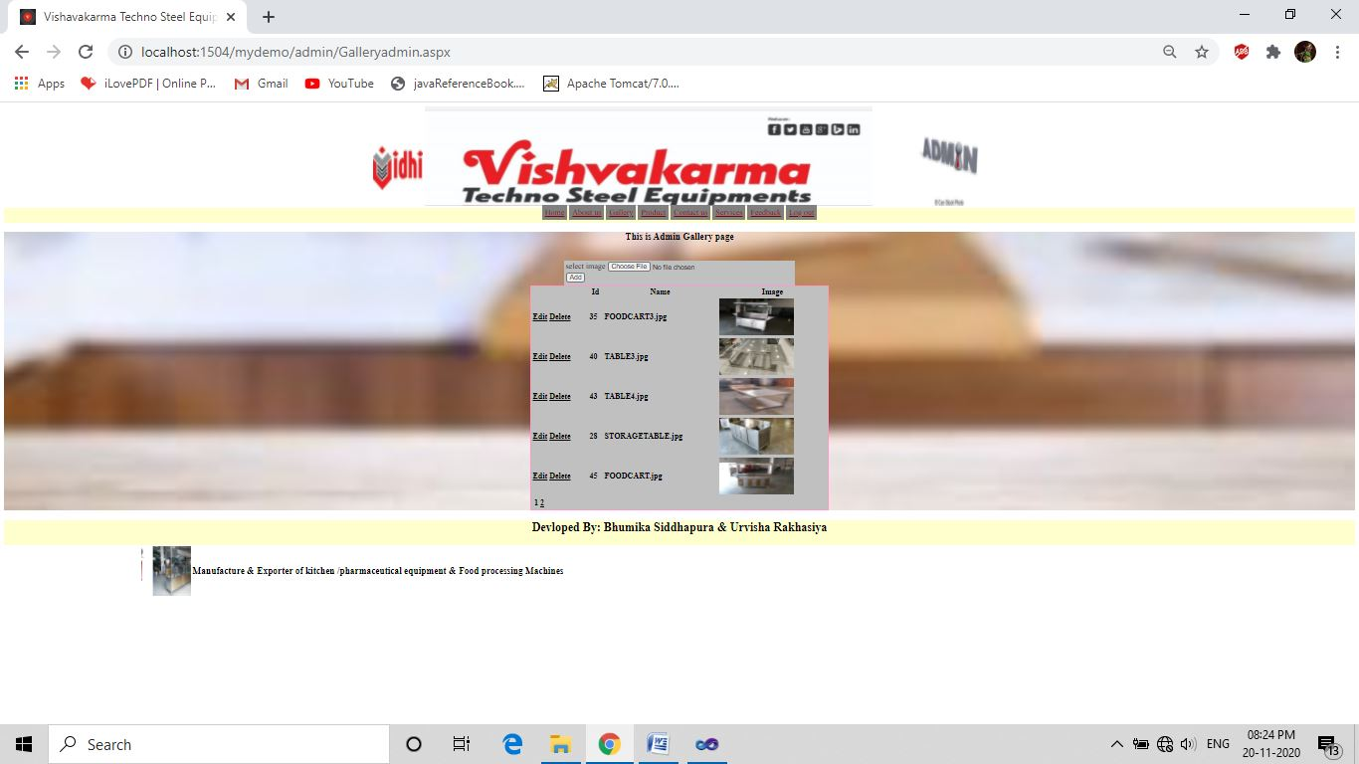

<%@ Page Title="" Language="C#" MasterPageFile="~/admin/MasterPageadmin.master" AutoEventWireup="true" CodeFile="Galleryadmin.aspx.cs" Inherits="admin_Galleryadmin" %>

<%@ OutputCache Duration=1 NoStore="true" VaryByParam=none%>

<asp:Content ID="Content1" ContentPlaceHolderID="head" Runat="Server">

<style type="text/css">

.style1

{ width: 61px; }

.mydiv

{ border: 5px outside Blue;

border-color: Blue;

text-align:center;

background-color:Gray;

background-image:url("../images/BACKGROUND IMAGE.jpg");

background-position:center;

background-repeat:no-repeat;

background-size:cover;

}

.table

{ background-color: Silver; }

</style>

</asp:Content>

<asp:Content ID="Content2" ContentPlaceHolderID="ContentPlaceHolder1" Runat="Server">

<div class="mydiv">

<center>

<h3>This is Admin Gallery page</h3><br />

<table class="table">

<tr>

<td>

<asp:Label ID="lblimgupload" runat="server" Text="select image"></asp:Label>

</td>

<td>

<asp:FileUpload ID="FileUpload1" runat="server" />

<asp:RequiredFieldValidator ID="RequiredFieldValidator1" runat="server" ErrorMessage="Must select image"

ControlToValidate="FileUpload1" ValidationGroup="grpaddimge"></asp:RequiredFieldValidator>

</td>

</tr>

<tr > <td >

<asp:Button ID="btnadd" runat="server" Text="Add"

onclick="btnadd_Click" ValidationGroup="grpaddimge" />

</td> </tr>

<tr >

<td colspan="2"> <asp:Label ID="lblmsg" runat="server" Text=""></asp:Label></td>

</tr>

</table>

<asp:SqlDataSource ID="SqlDataSource1" runat="server"

ConnectionString="<%$ ConnectionStrings:ConnectionString %>"

SelectCommand="SELECT * FROM [T_Gallery]"

InsertCommand="insert into[T_Gallery]([G_Name],[G_image])values(@G_Name,@G_image)"

DeleteCommand="delete from T_Gallery where G_id=@G_id;"

UpdateCommand="update T_Gallery set G_Name=@G_Name where G_id=@G_id;">

<DeleteParameters>

<asp:ControlParameter ControlID="GridView1" Name="G_id"

PropertyName="SelectedValue" />

</DeleteParameters>

<InsertParameters>

<asp:Parameter Name="G_Name" Type="String" />

<asp:Parameter Name="G_image" Type="String" />

</InsertParameters>

<UpdateParameters>

<asp:ControlParameter ControlID="GridView1" Name="G_Name"

PropertyName="SelectedValue" />

<asp:ControlParameter ControlID="GridView1" Name="G_id"

PropertyName="SelectedValue" />

</UpdateParameters>

</asp:SqlDataSource>

<asp:GridView ID="GridView1" runat="server" AutoGenerateColumns="False"

AutoGenerateDeleteButton="True" AutoGenerateEditButton="True"

DataSourceID="SqlDataSource1" BackColor="Silver" BorderColor="#FF99CC"

BorderStyle="Solid" BorderWidth="2px" CellSpacing="1"

FooterStyle-ForeColor="Black" ForeColor="Black" Font-Underline="False"

Font-Bold="True" Font-Italic="True" DataKeyNames="G_id" AllowPaging="True"

CellPadding="3" GridLines="None" Height="200px" PageSize="5" Width="600px">

<Columns>

<asp:BoundField DataField="G_id" HeaderText="id" SortExpression="G_id"

InsertVisible="False" ReadOnly="True" />

<asp:BoundField DataField="G_Name" HeaderText="Name"

SortExpression="G_Name" />

<asp:TemplateField HeaderText="G_Image">

<ItemTemplate>

<asp:Image ID="Image1" runat="server" ImageUrl='<%# "~/images/"+Eval("G_image") %>' Height="75px" Width="150px" />

</ItemTemplate>

</asp:TemplateField>

</Columns>

</asp:GridView>

</center>

</div>

</asp:Content>

* **Galleryadmin.aspx.cs**

using System;

using System.Collections.Generic;

using System.Linq;

using System.Web;

using System.Web.UI;

using System.Web.UI.WebControls;

using System.Data.SqlClient;

public partial class admin_Galleryadmin : System.Web.UI.Page

{ SqlConnection con = new SqlConnection("Data Source=.\\SQLEXPRESS;AttachDbFilename=|DataDirectory|\\Databaseproject.mdf;Integrated Security=True;User Instance=True");

protected void Page_Load(object sender, EventArgs e)

{ con.Open(); }

protected void btnadd_Click(object sender, EventArgs e)

{ string str2 = Server.MapPath("~/images");

string apppath = Request.PhysicalApplicationPath;

if (FileUpload1.HasFile == true)

{ str2 = str2 + "\\" + FileUpload1.FileName;

String extension = System.IO.Path.GetExtension(str2);

if (extension == ".jpg" || extension == ".jpeg")

{ FileUpload1.SaveAs(str2);

SqlCommand cmd = new SqlCommand("insert into T_Gallery(G_Name,G_image)values('" + FileUpload1.FileName.ToString() + "','" + FileUpload1.PostedFile.FileName + "')", con);

cmd.ExecuteNonQuery();

Response.Write("<script> alert('Add sucessfully')</script>");

Response.Redirect("~/admin/Galleryadmin.aspx");

con.Close();

}

else

{ lblmsg.Text = "your file is not extented with .jpg or .jpeg formate";

}

}

}

}

* Productadmin.aspx

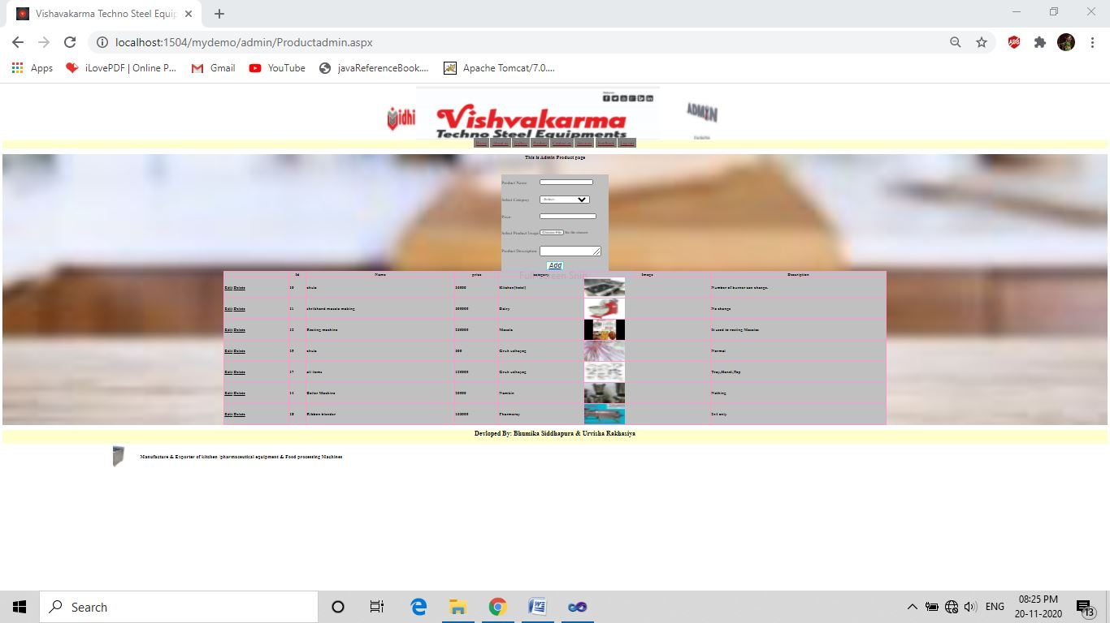

<%@ Page Title="" Language="C#" MasterPageFile="~/admin/MasterPageadmin.master" AutoEventWireup="true" CodeFile="Productadmin.aspx.cs" Inherits="admin_Productadmin" %>

<%@ OutputCache Duration=1 NoStore="true" VaryByParam=none%>

<asp:Content ID="Content1" ContentPlaceHolderID="head" Runat="Server">

<style type="text/css">

.mydiv

{

border: 5px outside Blue;

border-color: Blue;

text-align:center;

background-color:Gray;

background-image:url("../images/BACKGROUND IMAGE.jpg");

background-position:center;

background-repeat:no-repeat;

background-size:cover;

}

.table

{

background-color: Silver;

}

</style>

</asp:Content>

<asp:Content ID="Content2" ContentPlaceHolderID="ContentPlaceHolder1" Runat="Server">

<div class="mydiv">

<center>

<h3>This is Admin Product page</h3><br />

<table style="background-color: Silver;">

<tr>

<td class="td">

<asp:Label ID="lblnm" runat="server" Text="Product Name:" EnableViewState="False" ></asp:Label>

</td>

<td class="td">

<br />

<asp:TextBox ID="txtpronm" runat="server" Width="188px"

ValidationGroup="productadd" ></asp:TextBox>

<br />

<asp:RequiredFieldValidator ID="RequiredFieldValidator1" runat="server"

ControlToValidate="txtpronm" ErrorMessage="Must Enter product Name" Font-Bold="True"

Font-Italic="True" ForeColor="Red" ValidationGroup="productadd"></asp:RequiredFieldValidator>

</td>

</tr>

<tr>

<td class="td">

<asp:Label ID="lblcat" runat="server" Text="Select Category" ></asp:Label>

</td>

<td class="td">

<br />

<asp:DropDownList ID="ddlcat" runat="server" Height="30px" Width="185px"

ValidationGroup="productadd"></asp:DropDownList>

<br />

<asp:RequiredFieldValidator ID="RequiredFieldValidator5" runat="server"

ControlToValidate="ddlcat" ErrorMessage="Must select category"

Font-Bold="True" Font-Italic="True" ForeColor="Red"

ValidationGroup="productadd"></asp:RequiredFieldValidator>

<br /> </td>

</tr>

<tr>

<td class="td">

<asp:Label ID="lblproprice" runat="server" Text="Price:" ></asp:Label>

</td>

<td class="td">

<br />

<asp:TextBox ID="txtProprice" runat="server" Width="199px"

ValidationGroup="productadd"></asp:TextBox>

<br />

<asp:RequiredFieldValidator ID="RequiredFieldValidator2" runat="server"

ControlToValidate="txtProprice" ErrorMessage="Must Enter Product Price"

Font-Bold="True" Font-Italic="True" ForeColor="Red"

ValidationGroup="productadd"></asp:RequiredFieldValidator>

<br /> </td>

</tr> <tr>

<td class="td">

<asp:Label ID="lblimg" runat="server" Text="Select Product Image" ></asp:Label>

</t>

<td class="td">

<br />

<asp:FileUpload ID="proimg" runat="server" />

<br />

<asp:RequiredFieldValidator ID="RequiredFieldValidator3" runat="server"

ControlToValidate="txtProprice" ErrorMessage="Must select Product Image"

Font-Bold="True" Font-Italic="True" ForeColor="Red"

ValidationGroup="productadd"></asp:RequiredFieldValidator>

<br />

</td>

</tr>

<tr>

<td class="td">

<asp:Label ID="lblprodes" runat="server" Text="Product Description:" ></asp:Label>

</td>

<td class="td">

<br />

<asp:TextBox ID="txtprodes" runat="server" TextMode="MultiLine" Width="216px"

ValidationGroup="productadd"></asp:TextBox>

<br />

<asp:RequiredFieldValidator ID="RequiredFieldValidator4" runat="server"

ControlToValidate="txtprodes"

ErrorMessage="Must Enter Description" Font-Bold="True"

Font-Italic="True" ForeColor="Red" ValidationGroup="productadd"></asp:RequiredFieldValidator>

<br />

</td>

</tr>

<br />

<tr>

<td colspan="2" align="center">

<asp:Button ID="btnadd" runat="server" Text="Add" Font-Italic="True"

Font-Bold="True" Font-Underline="True" ForeColor="#003399"

BorderColor="#66CCFF" BorderStyle="Solid" BackColor="#FFFFCC"

Font-Size="X-Large" ValidationGroup="productadd" onclick="btnadd_Click" ></asp:Button>

</td>

</tr>

<tr>

<td colspan="3" align="center">

<asp:Label ID="lblmsg" runat="server" Text="" Font-Bold="True"

Font-Italic="True" Font-Size="Larger" Font-Names="Arial" ForeColor="#FF3300"></asp:Label>

</td>

</tr>

</table>

<asp:GridView ID="GridView1" runat="server" AutoGenerateColumns="False"

AutoGenerateDeleteButton="True" AutoGenerateEditButton="True"

DataKeyNames="p_id" DataSourceID="SqlDataSource1" BackColor="Silver"

BorderColor="#FF99CC" BorderStyle="Solid" BorderWidth="2PX" CellSpacing="1"

ClientIDMode="Inherit" FooterStyle-ForeColor="Black" ForeColor="Black"

Font-Underline="False" Font-Bold="True" Font-Italic="True" Height="60%"

Width="60%" >

<Columns>

<asp:BoundField DataField="P_id" HeaderText="id" InsertVisible="False"

ReadOnly="True" SortExpression="P_id" />

<asp:BoundField DataField="P_Name" HeaderText="Name"

SortExpression="P_Name" />

<asp:BoundField DataField="P_price" HeaderText="price"

SortExpression="P_price" />

<asp:BoundField DataField="P_cat" HeaderText="category" SortExpression="P_cat" />

<asp:TemplateField HeaderText="Image">

<ItemTemplate>

<asp:Image ID="Image1" runat="server" ImageUrl='<%# "~/images/product/"+Eval("P_img") %>' Height="75px" Width="150px" />

</ItemTemplate>

</asp:TemplateField>

<asp:BoundField DataField="P_des" HeaderText="Description" SortExpression="P_des" />

</Columns>

</asp:GridView>

<asp:SqlDataSource ID="SqlDataSource1" runat="server"

ConnectionString="<%$ ConnectionStrings:ConnectionString %>"

SelectCommand="SELECT * FROM [T_Product]"

DeleteCommand="delete from T_Product where P_id=@P_id;"

UpdateCommand="update T_Product set P_Name=@P_Name,P_price=@p_price,P_des=@P_des where P_id=@P_id;">

<DeleteParameters>

<asp:ControlParameter ControlID="GridView1" Name="P_id"

PropertyName="SelectedValue" />

</DeleteParameters>

<UpdateParameters>

<asp:ControlParameter ControlID="GridView1" Name="P_Name"

PropertyName="SelectedValue" />

<asp:ControlParameter ControlID="GridView1" Name="p_price"

PropertyName="SelectedValue" />

<asp:ControlParameter ControlID="GridView1" Name="P_des"

PropertyName="SelectedValue" />

<asp:ControlParameter ControlID="GridView1" Name="P_id"

PropertyName="SelectedValue" />

</UpdateParameters>

</asp:SqlDataSource>

</div>

</asp:Content>

* **Productadmin.aspx.cs**

using System;

using System.Collections.Generic;

using System.Linq;

using System.Web;

using System.Web.UI;

using System.Web.UI.WebControls;

using System.Data.SqlClient;

public partial class admin_Productadmin : System.Web.UI.Page

{

SqlConnection con = new SqlConnection("Data Source=.\\SQLEXPRESS;AttachDbFilename=|DataDirectory|\\Databaseproject.mdf;Integrated Security=True;User Instance=True");

SqlDataReader dr;

protected void Page_Load(object sender, EventArgs e)

{

string constr = "Data Source=.\\SQLEXPRESS;AttachDbFilename=|DataDirectory|\\Databaseproject.mdf;Integrated Security=True;User Instance=True";

SqlConnection con = new SqlConnection(constr);

string str = "select cat_Name from T_Category ";

SqlCommand cmd = new SqlCommand(str, con);

con.Open();

if (!IsPostBack)

{

dr = cmd.ExecuteReader();

ddlcat.DataSource = dr;

ddlcat.DataTextField = "cat_Name";

ddlcat.DataValueField = "cat_Name";

ddlcat.DataBind();

ddlcat.Items.Insert(0, new ListItem("--Select--", "0"));

dr.Close();

}

}

protected void btnadd_Click(object sender, EventArgs e)

{

string str2 = Server.MapPath("~/images/product");

string apppath = Request.PhysicalApplicationPath;

if (proimg.HasFile == true)

{

str2 = str2 + "\\" + proimg.FileName;

String extension = System.IO.Path.GetExtension(str2);

if (extension == ".jpg" || extension == ".jpeg")

{

proimg.SaveAs(str2);

SqlCommand cmd = new SqlCommand("insert into T_Product values(@P_Name,@P_price,@P_cat,@P_img,@P_des)");

con.Open();

cmd.Connection = con;

cmd.Parameters.AddWithValue("@P_Name", txtpronm.Text);

cmd.Parameters.AddWithValue("@P_price", txtProprice.Text);

cmd.Parameters.AddWithValue("@P_cat", ddlcat.SelectedItem.Text);

cmd.Parameters.AddWithValue("@P_img", proimg.FileName);

cmd.Parameters.AddWithValue("@P_des", txtprodes.Text);

cmd.ExecuteNonQuery();

Response.Redirect("~/admin/Productadmin.aspx");

con.Close();

}

else

{ lblmsg.Text = "your file is not extented with .jpg or .jpeg formate";

}

}

}

}

* **contactusadmin.aspx**

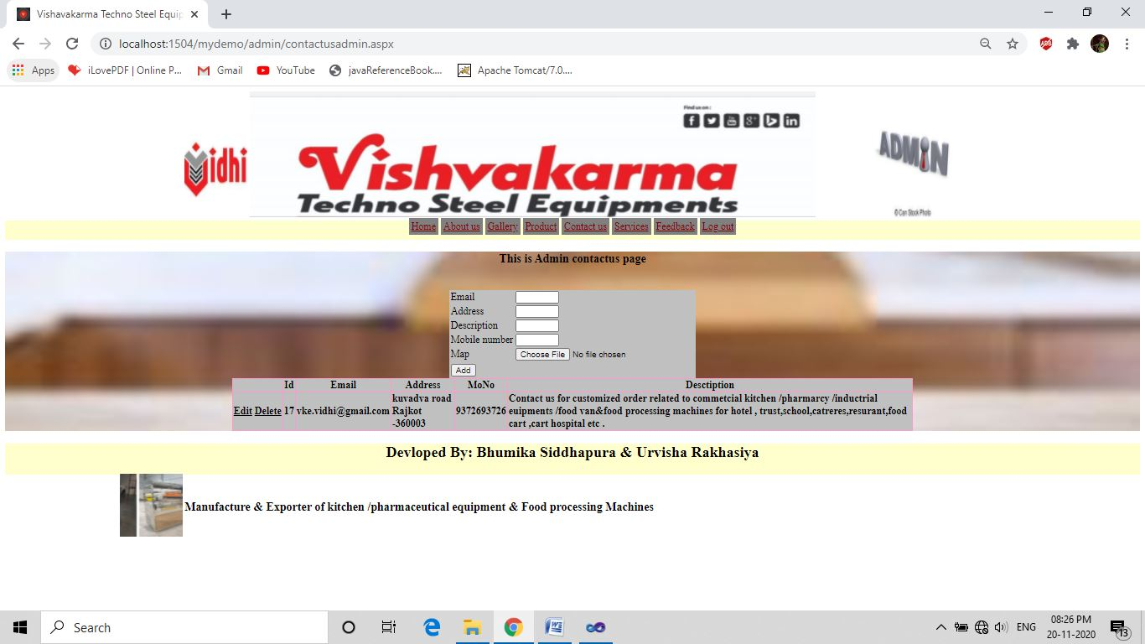<%@ Page Title="" Language="C#" MasterPageFile="~/admin/MasterPageadmin.master" AutoEventWireup="true" CodeFile="contactusadmin.aspx.cs" Inherits="admin_contactusadmin" %>

<%@ OutputCache Duration=1 NoStore="true" VaryByParam=none%>

<asp:Content ID="Content1" ContentPlaceHolderID="head" Runat="Server">

<style type="text/css">

.style1

{ width: 61px; }

.mydiv

{ border: 5px outside Blue;

border-color: Blue;

text-align:center;

background-color:Gray;

background-image:url("../images/BACKGROUND IMAGE.jpg");

background-position:center;

background-repeat:no-repeat;

background-size:cover;

}

.table

{ background-color: Silver; }

</style>

</asp:Content>

<asp:Content ID="Content2" ContentPlaceHolderID="ContentPlaceHolder1" Runat="Server">

<div class="mydiv">

<center>

<h3>This is Admin contactus page</h3><br />

<table class="table">

<tr>

<td><asp:Label ID="lblconemail" runat="server" Text="Email"> </asp:Label></td>

<td><asp:TextBox ID="txtconemail" runat="server" class="style1"

ValidationGroup="grpcontactusadd" ></asp:TextBox>

</td>

</tr>

<tr>

<td><asp:Label ID="lblconaddress" runat="server" Text="Address"> </asp:Label></td>

<td><asp:TextBox ID="txtconaddress" runat="server" class="style1"

ValidationGroup="grpcontactusadd" ></asp:TextBox>

</td>

</tr>

<tr>

<td><asp:Label ID="lblcondescription" runat="server" Text="Description"> </asp:Label></td>

<td><asp:TextBox ID="txtcondescription" runat="server" class="style1"

ValidationGroup="grpcontactusadd" ></asp:TextBox>

<asp:RequiredFieldValidator ID="RequiredFieldValidator2" runat="server"

ErrorMessage="Description is complasory to add"

ControlToValidate="txtcondescription" ValidationGroup="grpcontactusadd"></asp:RequiredFieldValidator></td>

</tr>

<tr>

<td><asp:Label ID="lblconmono" runat="server" Text="Mobile number"> </asp:Label></td>

<td><asp:TextBox ID="txtconmono" runat="server" class="style1"

ValidationGroup="grpcontactusadd" ></asp:TextBox></td>

</tr>

<tr>

<td><asp:Label ID="lblconmap" runat="server" Text="Map"> </asp:Label></td>

<td>

<asp:FileUpload ID="FileUpload1" runat="server" />

<asp:Label ID="lblflup" runat="server" > </asp:Label>

</td></tr>

<tr><td colspan="2"><asp:Label ID="lblmsg" runat="server" Text=""></asp:Label></td></tr>

<tr>

<td colspan="2">

<asp:Button ID="btnadd" runat="server" Text="Add" onclick="btnadd_Click"

ValidationGroup="grpcontactusadd" /></td>

</table>

<asp:GridView ID="GridView1" runat="server" AutoGenerateColumns="False"

AutoGenerateDeleteButton="True" AutoGenerateEditButton="True"

DataKeyNames="cu_id" DataSourceID="SqlDataSource1" BackColor="Silver"

BorderColor="#FF99CC" BorderStyle="Solid" BorderWidth="2PX" CellSpacing="1"

ClientIDMode="Inherit" FooterStyle-ForeColor="Black" ForeColor="Black"

Font-Underline="False" Font-Bold="True" Height="60%"

Width="60%">

<Columns>

<asp:BoundField DataField="cu_id" HeaderText="Id" InsertVisible="False"

ReadOnly="True" SortExpression="cu_id" />

<asp:BoundField DataField="cu_email" HeaderText="Email"

SortExpression="cu_email" />

<asp:BoundField DataField="cu_add" HeaderText="Address"

SortExpression="cu_add" />

<asp:BoundField DataField="cu_MoNo" HeaderText="MoNo"

SortExpression="cu_MoNo" />

<asp:BoundField DataField="cu_des" HeaderText="Desctiption"

SortExpression="cu_des" />

</Columns>

</asp:GridView>

<asp:SqlDataSource ID="SqlDataSource1" runat="server"

ConnectionString="Data Source=.\SQLEXPRESS;AttachDbFilename=|DataDirectory|\Databaseproject.mdf;Integrated Security=True;User Instance=True"

DeleteCommand="delete from T_Contactus where cu_id=@cu_id;"

ProviderName="System.Data.SqlClient"

SelectCommand="SELECT * FROM [T_Contactus]"

UpdateCommand="update T_Contactus set cu_email=@cu_email,cu_add=@cu_add,cu_MoNo=@cu_MoNo,cu_map=@cu_map,cu_des=@cu_des where cu_id=@cu_id;"

InsertCommand="insert into T_Contactus values(@cu_email,@cu_add,@cu_MoNo,@cu_map,@cu_des)">

<InsertParameters>

<asp:Parameter Name="cu_email" Type="String" />

<asp:Parameter Name="cu_add" Type="String" />

<asp:Parameter Name="cu_MoNo" Type="String" />

<asp:Parameter Name="cu_map" Type="String" />

<asp:Parameter Name="cu_des" Type="String" />

</InsertParameters>

<DeleteParameters>

<asp:ControlParameter ControlID="GridView1" Name="cu_id"

PropertyName="SelectedValue" />

</DeleteParameters>

<UpdateParameters>

<asp:ControlParameter ControlID="GridView1" Name="cu_email"

PropertyName="SelectedValue" />

<asp:ControlParameter ControlID="GridView1" Name="cu_add"

PropertyName="SelectedValue" />

<asp:ControlParameter ControlID="GridView1" Name="cu_MoNo"

PropertyName="SelectedValue" />

<asp:ControlParameter ControlID="GridView1" Name="cu_map"

PropertyName="SelectedValue" />

<asp:ControlParameter ControlID="GridView1" Name="cu_des"

PropertyName="SelectedValue" />

<asp:ControlParameter ControlID="GridView1" Name="cu_id"

PropertyName="SelectedValue" />

</UpdateParameters>

</asp:SqlDataSource>

</center>

</div>

</asp:Content>

* Contactusadmin.aspx.cs

using System;

using System.Collections.Generic;

using System.Linq;

using System.Web;

using System.Web.UI;

using System.Web.UI.WebControls;

using System.Data.SqlClient;

public partial class admin_contactusadmin : System.Web.UI.Page

{

protected void Page_Load(object sender, EventArgs e)

{ }

protected void btnadd_Click(object sender, EventArgs e)

{

string constr = "Data Source=.\\SQLEXPRESS;AttachDbFilename=|DataDirectory|\\Databaseproject.mdf;Integrated Security=True;User Instance=True";

SqlConnection con = new SqlConnection(constr);

con.Open();

string str2 = Server.MapPath("~/images");

string apppath = Request.PhysicalApplicationPath;

if (FileUpload1.HasFile == true)

{

str2 = str2 + "\\" + FileUpload1.FileName;

String extension = System.IO.Path.GetExtension(str2);

if (extension == ".jpg" || extension == ".jpeg")

{

FileUpload1.SaveAs(str2);

}

else

{

lblmsg.Text = "your file is not extented with .jpg or .jpeg formate";

}

}

string str = "insert into T_Contactus (cu_email,cu_add,cu_MoNo,cu_map,cu_des) values('" + txtconemail.Text + "','" + txtconaddress.Text + "','" + txtconmono.Text + "','" + FileUpload1.PostedFile.FileName + "','"+txtcondescription.Text+"')";

SqlCommand cmd = new SqlCommand(str, con);

int ans1 = cmd.ExecuteNonQuery();

if (ans1 > 0)

{

lblmsg.Text = "record added....";

}

else

{

lblmsg.Text = "errorr occurr.........";

}

Response.Redirect("contactusadmin.aspx");

}

}

* **servicesadmin.aspx**

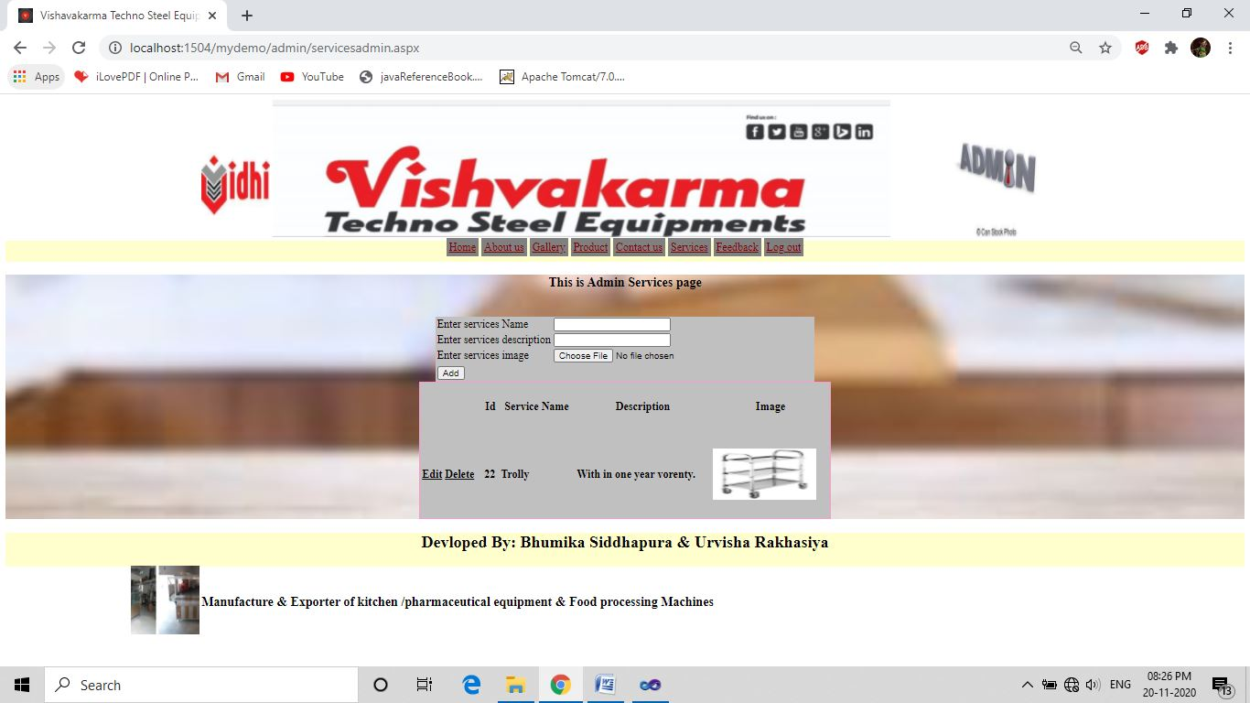

<%@ Page Title="" Language="C#" MasterPageFile="~/admin/MasterPageadmin.master" AutoEventWireup="true" CodeFile="servicesadmin.aspx.cs" Inherits="admin_servicesadmin" %>

<%@ OutputCache Duration=1 NoStore="true" VaryByParam=none%>

<asp:Content ID="Content1" ContentPlaceHolderID="head" Runat="Server">

<style type="text/css">

.style1

{ width: 61px; }

.mydiv

{ border: 5px outside Blue;

border-color: Blue;

text-align:center;

background-color:Gray;

background-image:url("../images/BACKGROUND IMAGE.jpg");

background-position:center;

background-repeat:no-repeat;

background-size:cover;

}

.table

{ background-color: Silver; }

</style>

</asp:Content>

<asp:Content ID="Content2" ContentPlaceHolderID="ContentPlaceHolder1" Runat="Server">

<div class="mydiv">

<center> <h3>This is Admin Services page</h3><br />

<table class="table"><tr><td>

<asp:Label ID="lblsernm" runat="server" Text="Enter services Name"></asp:Label></td>

<td><asp:TextBox ID="txtsernm" runat="server" ValidationGroup="grpserviceadd"></asp:TextBox>

<asp:RequiredFieldValidator ID="RequiredFieldValidator2" runat="server"

ErrorMessage="Must Enter Service Name"

ControlToValidate="txtsernm" ValidationGroup="grpserviceadd"></asp:RequiredFieldValidator>

</td></tr><tr><td>

<asp:Label ID="lblserdes" runat="server" Text="Enter services description"></asp:Label></td>

<td><asp:TextBox ID="txtserdes" runat="server" ValidationGroup="grpserviceadd"></asp:TextBox>

<asp:RequiredFieldValidator ID="RequiredFieldValidator1" runat="server"

ErrorMessage="Must Enter Service Description"

ControlToValidate="txtserdes" ValidationGroup="grpserviceadd"></asp:RequiredFieldValidator></td>

</tr><tr><td>

<asp:Label ID="lblserimg" runat="server" Text="Enter services image"></asp:Label>

</td><td>

<asp:FileUpload ID="FileUpload1" runat="server" />

<asp:RequiredFieldValidator ID="RequiredFieldValidator3" runat="server"

ErrorMessage="Must select image"

ControlToValidate="FileUpload1" ValidationGroup="grpserviceadd"></asp:RequiredFieldValidator>

</td>

</tr><tr><td colspan="2">

<asp:Label ID="lblmsg" runat="server" Text=""></asp:Label>

</td></tr><tr>

<td colspan="2">

<asp:Button ID="btnadd" runat="server" Text="Add" onclick="btnadd_Click"

ValidationGroup="grpserviceadd"/>

</td></tr>

</table>

<asp:SqlDataSource ID="SqlDataSource1" runat="server"

ConnectionString="<%$ ConnectionStrings:ConnectionString %>"

SelectCommand="SELECT * FROM [T_Services]"

InsertCommand="insert into[T_services]([ser_Name],[ser_des],[ser_img])values(@ser_Name,@ser_des,@ser_img);"

DeleteCommand="delete from T_services where ser_id=@ser_id;"

UpdateCommand="update T_services set ser_Name=@ser_Name,ser_des=@ser_des where ser_id=@ser_id;">

<DeleteParameters>

<asp:ControlParameter ControlID="GridView1" Name="ser_id"

PropertyName="SelectedValue" />

</DeleteParameters>

<InsertParameters>

<asp:Parameter Name="ser_Nmae" Type="String" />

<asp:Parameter Name="ser_des" Type="String" />

<asp:Parameter Name="ser_img" Type="String" />

</InsertParameters>

<UpdateParameters>

<asp:ControlParameter ControlID="GridView1" Name="ser_Name"

PropertyName="SelectedValue" />

<asp:ControlParameter ControlID="GridView1" Name="ser_des"

PropertyName="SelectedValue" />

<asp:ControlParameter ControlID="GridView1" Name="ser_id"

PropertyName="SelectedValue" />

</UpdateParameters>

</asp:SqlDataSource>

<asp:GridView ID="GridView1" runat="server" AutoGenerateColumns="False"

AutoGenerateDeleteButton="True" AutoGenerateEditButton="True"

DataSourceID="SqlDataSource1" BackColor="Silver" BorderColor="#FF99CC"

BorderStyle="Solid" BorderWidth="2px" CellSpacing="1"

FooterStyle-ForeColor="Black" ForeColor="Black" Font-Underline="False"

Font-Bold="True" DataKeyNames="ser_id" AllowPaging="True"

CellPadding="3" GridLines="None" Height="200px" PageSize="5" Width="600px">

<Columns>

<asp:BoundField DataField="ser_id" HeaderText="Id" SortExpression="ser_id"

InsertVisible="False" ReadOnly="True" />

<asp:BoundField DataField="ser_Name" HeaderText=" Service Name"

SortExpression="ser_Name" />

<asp:BoundField DataField="ser_des" HeaderText="Description"

SortExpression="ser_des" />

<asp:TemplateField HeaderText="Image">

<ItemTemplate>

<asp:Image ID="Image1" runat="server" ImageUrl='<%# "~/images/"+Eval("ser_img") %>' Height="75px" Width="150px" />

</ItemTemplate>

</asp:TemplateField>

</Columns>

</asp:GridView>

</center>

</div>

</asp:Content>

* **Servicesadmin.aspx.cs**

using System;

using System.Collections.Generic;

using System.Linq;

using System.Web;

using System.Web.UI;

using System.Web.UI.WebControls;

using System.Data.SqlClient;

public partial class admin_servicesadmin : System.Web.UI.Page

{ SqlConnection con = new SqlConnection("Data Source=.\\SQLEXPRESS;AttachDbFilename=|DataDirectory|\\Databaseproject.mdf;Integrated Security=True;User Instance=True");

protected void Page_Load(object sender, EventArgs e)

{ con.Open(); }

protected void btnadd_Click(object sender, EventArgs e)

{ string str2 = Server.MapPath("~/images");

string apppath = Request.PhysicalApplicationPath;

if (FileUpload1.HasFile == true)

{

str2 = str2 + "\\" + FileUpload1.FileName;

String extension = System.IO.Path.GetExtension(str2);

if (extension == ".jpg" || extension == ".jpeg")

{

FileUpload1.SaveAs(str2);

SqlCommand cmd = new SqlCommand("insert into T_services(ser_Name,ser_des,ser_img)values('" + txtsernm.Text + "','"+txtserdes.Text+"','" + FileUpload1.PostedFile.FileName + "')", con);

cmd.ExecuteNonQuery();

Response.Write("<script> alert('Add sucessfully')</script>");

Response.Redirect("~/admin/servicesadmin.aspx");

con.Close();

}

else

{

lblmsg.Text = "your file is not extented with .jpg or .jpeg formate";

}

}

}

}

* **feedbackadmin.aspx**

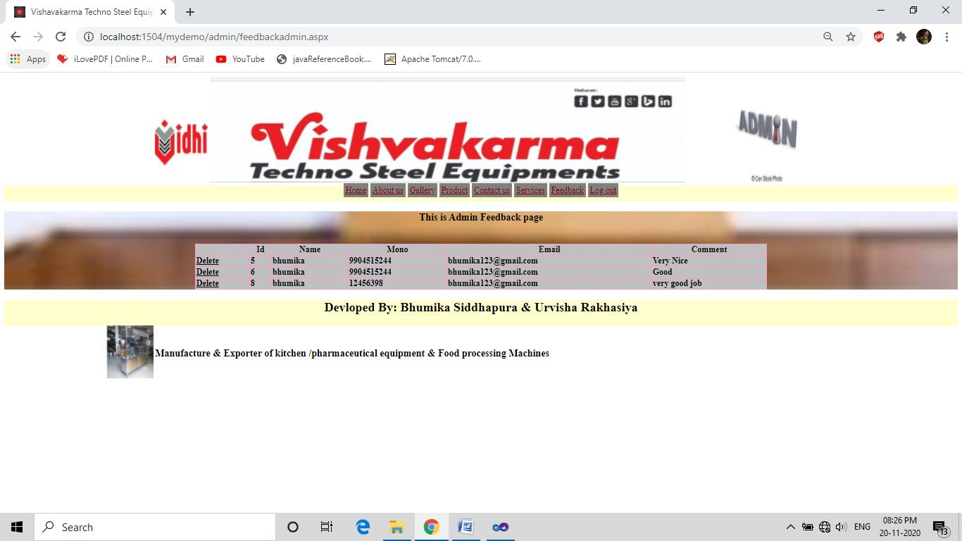

<%@ Page Title="" Language="C#" MasterPageFile="~/admin/MasterPageadmin.master" AutoEventWireup="true" CodeFile="feedbackadmin.aspx.cs" Inherits="admin_feedbackadmin" %>

<%@ OutputCache Duration=1 NoStore="true" VaryByParam=none%>

<asp:Content ID="Content1" ContentPlaceHolderID="head" Runat="Server">

<style type="text/css">

.style1

{ width: 61px; }

.mydiv

{ border: 5px outside Blue;

border-color: Blue;

text-align:center;

background-color:Gray;

background-image:url("../images/BACKGROUND IMAGE.jpg");

background-position:center;

background-repeat:no-repeat;

background-size:cover;

}

.table

{ background-color: Silver; }

</style>

</asp:Content>

<asp:Content ID="Content2" ContentPlaceHolderID="ContentPlaceHolder1" Runat="Server">

<div class=mydiv>

<center>

<h3>This is Admin Feedback page</h3><br />

<asp:GridView ID="GridViewfeedback" runat="server" AutoGenerateColumns="False"

DataSourceID="SqlDataSource1" AutoGenerateDeleteButton="True"

BackColor="Silver" BorderColor="#FF99CC" BorderStyle="Solid" BorderWidth="2PX"

CellSpacing="1" ClientIDMode="Inherit" FooterStyle-ForeColor="Black"

ForeColor="Black" Font-Underline="False" Font-Bold="True"

DataKeyNames="F_id" Height="60%" Width="60%">

<Columns> <asp:BoundField DataField="F_id" HeaderText="Id" SortExpression="F_id" />

<asp:BoundField DataField="F_name" HeaderText="Name"

SortExpression="F_name" />

<asp:BoundField DataField="F_Mono" HeaderText="Mono"

SortExpression="F_Mono" />

<asp:BoundField DataField="F_email" HeaderText="Email"

SortExpression="F_email" />

<asp:BoundField DataField="F_comment" HeaderText="Comment"

SortExpression="F_comment" /> </Columns>

</asp:GridView> <asp:SqlDataSource ID="SqlDataSource1" runat="server"

ConnectionString="Data Source=.\SQLEXPRESS;AttachDbFilename=|DataDirectory|\Databaseproject.mdf;Integrated Security=True;User Instance=True"

ProviderName="System.Data.SqlClient"

SelectCommand="SELECT * FROM [T_Feedback]"

DeleteCommand="delete from T_Feedback where F_id=@F_id;">

<DeleteParameters>

<asp:ControlParameter ControlID="GridViewfeedback" Name="id"

PropertyName="SelectedValue" />

</DeleteParameters>

</asp:SqlDataSource>

</center>

</div></asp:Content>

* **feedbackadmin.aspx.cs**

using System;

using System.Collections.Generic;

using System.Linq;

using System.Web;

using System.Web.UI;

using System.Web.UI.WebControls;

public partial class admin_feedbackadmin : System.Web.UI.Page

{

protected void Page_Load(object sender, EventArgs e)

{

}

}

**logout.aspx**

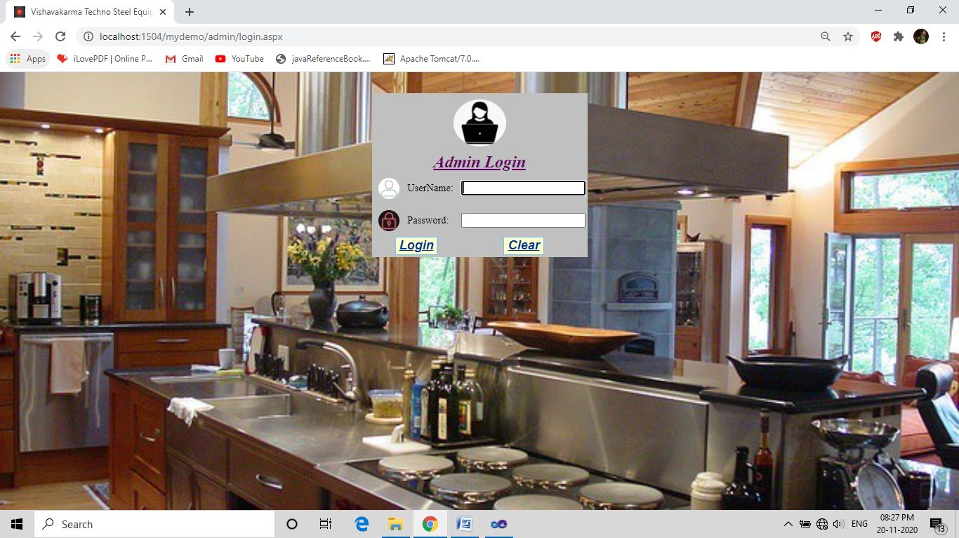

<%@ Page Title="" Language="C#" MasterPageFile="~/admin/MasterPageadmin.master" AutoEventWireup="true" CodeFile="logout.aspx.cs" Inherits="admin_logout" %>

<%@ OutputCache Duration=1 NoStore="true" VaryByParam=none%>

<asp:Content ID="Content1" ContentPlaceHolderID="head" Runat="Server">

</asp:Content>

<asp:Content ID="Content2" ContentPlaceHolderID="ContentPlaceHolder1" Runat="Server">

</asp:Content>

* **logout.aspx.cs**

using System;

using System.Collections.Generic;

using System.Linq;

using System.Web;

using System.Web.UI;

using System.Web.UI.WebControls;

public partial class admin_logout : System.Web.UI.Page

{ protected void Page_Load(object sender, EventArgs e)

{ Session.RemoveAll();

Session.Abandon();

Session.Clear();

Response.Redirect("~/admin/login.aspx");

}}

* **Client side:-**
* **MasterPageclient.master**

<%@ Master Language="C#" AutoEventWireup="true" CodeFile="MasterPageclient.master.cs" Inherits="MasterPageclient" %>

<!DOCTYPE html PUBLIC "-//W3C//DTD XHTML 1.0 Transitional//EN" "http://www.w3.org/TR/xhtml1/DTD/xhtml1-transitional.dtd">

<html xmlns="http://www.w3.org/1999/xhtml">

<head id="Head1" runat="server">

<link rel="icon" a href="~/images/url icon.jpg" />

<title> Vishavakarma Techno Steel Equipments</title>

<asp:ContentPlaceHolder id="head" runat="server">

</asp:ContentPlaceHolder>

</head>

<style>

.link

{ background-color: Gray;

border: solid;

border-color:Gray; }

.link:hover

{ background-color: transparent ;

text-transform: uppercase;

color: Blue;

}

.link:visited

{ background-color:Gray ;

text-transform: uppercase;

color: Maroon;

}

.link:active

{ background-color: transparent ;

text-transform: uppercase;

color: Green ; }

.bg

{ background-image:url("../images/VIEW.jpg");

background-position:center;

background-repeat:no-repeat;

background-size:cover;

}

}

</style>

<body>

<form id="form1" runat="server" class="bg">

<center>

<div >

<asp:Image ID="Image1" runat="server" ImageUrl="~/images/images (37).jpeg" Height="150px" Width="100px"/>

<asp:Image ID="headerimg" runat="server" ImageUrl="~/images/header image.jpg" Height="150px" Width="900px"/>

</div>

<asp:Panel ID="header" runat="server" BackColor="#FFFFCC" Height="30px" >

<asp:HyperLink ID="hyperhome" runat="server" NavigateUrl="~/homeclient.aspx" CssClass="link">Home</asp:HyperLink>

<asp:HyperLink ID="HyperAboutus" runat="server" NavigateUrl="~/aboutusclient.aspx" CssClass="link">About us</asp:HyperLink>

<asp:HyperLink ID="HyperGallery" runat="server" NavigateUrl="~/Galleryclient.aspx" CssClass="link">Gallery</asp:HyperLink>

<asp:HyperLink ID="HyperProduct" runat="server" NavigateUrl="~/productclient.aspx" CssClass="link">Product</asp:HyperLink>

<asp:HyperLink ID="HyperContactus" runat="server" NavigateUrl="~/contactusclient.aspx" CssClass="link">Contact us</asp:HyperLink>

<asp:HyperLink ID="Hyperservices" runat="server" NavigateUrl="~/servicesclient.aspx" CssClass="link" >Services</asp:HyperLink>

<asp:HyperLink ID="HyperFeedback" runat="server" NavigateUrl="~/feedbackclient.aspx" CssClass="link" >Feedback</asp:HyperLink>

</asp:Panel>

<asp:ContentPlaceHolder id="ContentPlaceHolder1" runat="server">

</asp:ContentPlaceHolder>

<div >

<asp:Panel ID="footer" runat="server" BackColor="#FFFFCC" Height="50px">

<marquee>

<h2> Devloped By: Bhumika Siddhapura & Urvisha Rakhasiya </h2>

</marquee>

</asp:Panel>

<table height="200px" width="70%" class="bg">

<tr>

<td height="100px" width="100px">

<marquee>

<asp:Image ID="mstImage1" runat="server" ImageUrl="~/images/3 STAGE TROLLY.jpg" Height="100px" width="100px"/>

<asp:Image ID="mstImage2" runat="server" ImageUrl="~/images/AATA MAKER.jpg" Height="100px" width="100px"/>

<asp:Image ID="mstImage3" runat="server" ImageUrl="~/images/DISPLAY COUNTER.jpg" Height="100px" width="100px"/>

<asp:Image ID="mstImage4" runat="server" ImageUrl="~/images/FOODCART.jpg" Height="100px" width="100px"/>

<asp:Image ID="mstImage5" runat="server" ImageUrl="~/images/FOODSERVTABLE.jpg" Height="100px" width="100px"/>

<asp:Image ID="mstImage6" runat="server" ImageUrl="~/images/FOODVAN.jpg" Height="100px" width="100px"/>

<asp:Image ID="mstImage7" runat="server" ImageUrl="~/images/STOVE WITH TABLE.jpg" Height="100px" width="100px"/></marquee>

</td>

<td text-align="center">

<h3> Manufacture & Exporter of kitchen /pharmaceutical equipment & Food processing Machinesg Machines</h3>

</td>

</tr>

</table>

</div>

</center>

</form>

</body>

</html>

* **MasterPageclient.master.cs**

using System;

using System.Collections.Generic;

using System.Linq;

using System.Web;

using System.Web.UI;

using System.Web.UI.WebControls;

public partial class MasterPageclient : System.Web.UI.MasterPage

{

protected void Page_Load(object sender, EventArgs e)

{

}

}

* **homeclient.aspx**



<%@ Page Title="" Language="C#" MasterPageFile="~/MasterPageclient.master" AutoEventWireup="true" CodeFile="homeclient.aspx.cs" Inherits="homeclient" %>

<%@ Register Assembly="System.Web.Extensions, Version=4.0.0.0, Culture=neutral, PublicKeyToken=31bf3856ad364e35"

Namespace="System.Web.UI" TagPrefix="asp" %>

<asp:Content ID="Content1" ContentPlaceHolderID="head" Runat="Server">

<style>

.mydiv

{ border: 5px outside Blue;

border-color: Blue;

text-align:center;

background-color:Silver;

background-image:url("../images/BACKGROUND IMAGE.jpg");

background-position:center;

background-repeat:no-repeat;

}

</style>

</asp:Content>

<asp:Content ID="Content2" ContentPlaceHolderID="ContentPlaceHolder1" Runat="Server">

<div height="300px"

width="500px" class="mydiv">

<asp:SqlDataSource ID="SqlDataSource1" runat="server"

ConnectionString="Data Source=.\SQLEXPRESS;AttachDbFilename=|DataDirectory|\Databaseproject.mdf;Integrated Security=True;User Instance=True"

ProviderName="System.Data.SqlClient" SelectCommand="SELECT * FROM [T_Home]">

</asp:SqlDataSource>

<center>

<asp:DataList ID="DataList1" runat="server" DataSourceID="SqlDataSource1"

Font-Names="Arial Unicode MS" Height="100px"

Width="500px" BackColor="#EAEAEA" ForeColor="#660033"

BorderColor="#B00058" BorderStyle="Solid" BorderWidth="3px">

<ItemTemplate>

<asp:Label ID="DescriptionLabel" runat="server"

Text='<%# Eval("Description") %>' />

</ItemTemplate>

</asp:DataList>

</center>

</div>

</asp:Content>

* **homeclient.aspx.cs**

using System;

using System.Collections.Generic;

using System.Linq;

using System.Web;

using System.Web.UI;

using System.Web.UI.WebControls;

public partial class homeclient : System.Web.UI.Page

{

protected void Page_Load(object sender, EventArgs e)

{

}

}

* **aboutusclient.aspx**

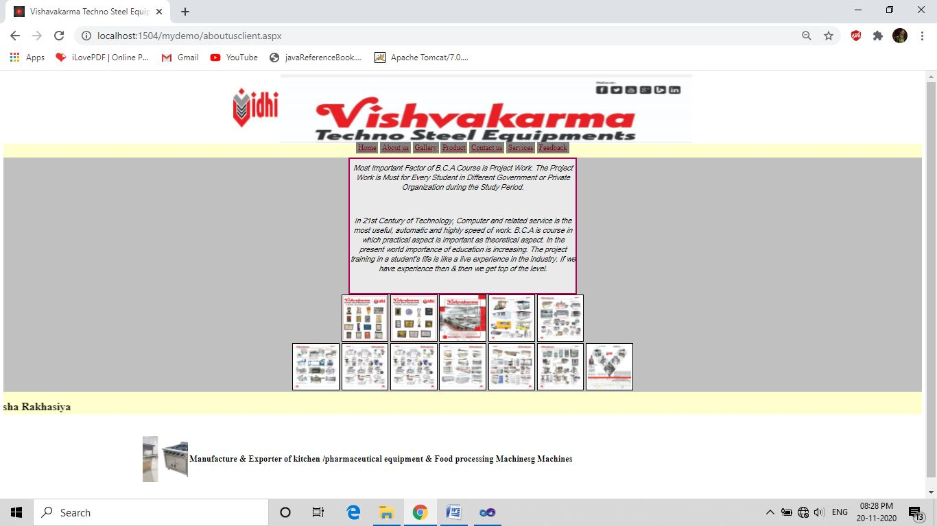

<%@ Page Title="" Language="C#" MasterPageFile="~/MasterPageclient.master" AutoEventWireup="true" CodeFile="aboutusclient.aspx.cs" Inherits="aboutusclient" %>

<asp:Content ID="Content1" ContentPlaceHolderID="head" Runat="Server">

<style>

.mydiv

{ border: 5px outside Blue;

border-color: Blue;

background-color:Silver; }

</style>

</asp:Content>

<asp:Content ID="Content2" ContentPlaceHolderID="ContentPlaceHolder1" Runat="Server">

<center>

<div class="mydiv">

<center>

<asp:DataList ID="DataList1" runat="server" DataSourceID="SqlDataSource1" Height="300px"

Width="500px" BackColor="#EAEAEA" BorderColor="#B00058" BorderStyle="Solid" BorderWidth="3px" >

<ItemTemplate>

<center>

<asp:Label ID="Abtu_desLabel" runat="server" Font-Italic="True" Font-Names="Arial Unicode MS" Text='<%# Eval("Abtu_des") %>' />

</center>

<br />

<br />

</ItemTemplate>

</asp:DataList>

<asp:SqlDataSource ID="SqlDataSource1" runat="server"

ConnectionString="Data Source=.\SQLEXPRESS;AttachDbFilename=|DataDirectory|\Databaseproject.mdf;Integrated Security=True;User Instance=True"

ProviderName="System.Data.SqlClient" SelectCommand="SELECT * FROM [T_Aboutus]">

</asp:SqlDataSource>

<asp:Image ID="mstImage1" runat="server" ImageUrl="~/images/gallery/certificate.jpg" Height="100px" width="100px" BorderColor="Black" BorderStyle="Solid" BorderWidth="1px" />

<asp:Image ID="mstImage2" runat="server" ImageUrl="~/images/gallery/certificate2.jpg" Height="100px" width="100px" BorderColor="Black" BorderStyle="Solid" BorderWidth="1px"/>

<asp:Image ID="Image1" runat="server" ImageUrl="~/images/images (41).jpeg" Height="100px" width="100px" BorderColor="Black" BorderStyle="Solid" BorderWidth="1px"/>

<asp:Image ID="mstImage7" runat="server" ImageUrl="~/images/images (44).jpeg" Height="100px" width="100px" BorderColor="Black" BorderStyle="Solid" BorderWidth="1px"/>

<asp:Image ID="mstImage6" runat="server" ImageUrl="~/images/download (3).jpeg" Height="100px" width="100px" BorderColor="Black" BorderStyle="Solid" BorderWidth="1px"/>

<br /> <asp:Image ID="Image2" runat="server" ImageUrl="~/images/images (42).jpeg" Height="100px" width="100px" BorderColor="Black" BorderStyle="Solid" BorderWidth="1px"/>

<asp:Image ID="Image3" runat="server" ImageUrl="~/images/images (43).jpeg" Height="100px" width="100px" BorderColor="Black" BorderStyle="Solid" BorderWidth="1px"/>

<asp:Image ID="Image5" runat="server" ImageUrl="~/images/images (43).jpeg" Height="100px" width="100px" BorderColor="Black" BorderStyle="Solid" BorderWidth="1px"/>

<asp:Image ID="mstImage3" runat="server" ImageUrl="~/images/download.jpeg" Height="100px" width="100px" BorderColor="Black" BorderStyle="Solid" BorderWidth="1px" />

<asp:Image ID="mstImage4" runat="server" ImageUrl="~/images/download (1).jpeg" Height="100px" width="100px" BorderColor="Black" BorderStyle="Solid" BorderWidth="1px"/>

<asp:Image ID="mstImage5" runat="server" ImageUrl="~/images/download (2).jpeg" Height="100px" width="100px" BorderColor="Black" BorderStyle="Solid" BorderWidth="1px"/>

<asp:Image ID="Image4" runat="server" ImageUrl="~/images/images (9).jpeg" Height="100px" width="100px" BorderColor="Black" BorderStyle="Solid" BorderWidth="1px"/>

</center>

</div>

</center>

</asp:Content>

* **Aboutusclient.aspx.cs**

using System;

using System.Collections.Generic;

using System.Linq;

using System.Web;

using System.Web.UI;

using System.Web.UI.WebControls;

public partial class aboutusclient : System.Web.UI.Page

{

protected void Page_Load(object sender, EventArgs e)

{

}

}

* **Galleryclient.aspx**

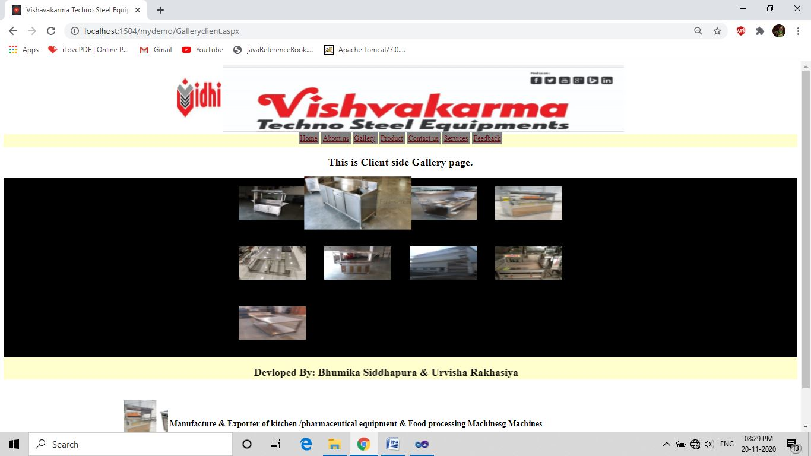

<%@ Page Title="" Language="C#" MasterPageFile="~/MasterPageclient.master" AutoEventWireup="true" CodeFile="Galleryclient.aspx.cs" Inherits="Galleryclient" %>

<asp:Content ID="Content1" ContentPlaceHolderID="head" Runat="Server">

<style>

.zoom

{ transition: transform .2s;

padding: 20px;

}

.zoom:hover

{ transform:scale(1.6);

}

.mydiv

{ border: 5px outside Blue;

border-color: Blue;

background-color:Black;

background-image:url("../images/BACKGROUND IMAGE.jpg");

background-position:center;

background-repeat:no-repeat;

background-size:cover;

}

</style>

</asp:Content>

<asp:Content ID="Content2" runat="server" contentplaceholderid="ContentPlaceHolder1">

<center>

<h2 align="center">This is Client side Gallery page.</h2>

<div class="mydiv" >

<asp:SqlDataSource ID="SqlDataSource1" runat="server"

ConnectionString="<%$ ConnectionStrings:ConnectionString %>"

SelectCommand="SELECT [G_image] FROM [T_Gallery]"></asp:SqlDataSource>

<asp:DataList ID="DataList1" runat="server" DataSourceID="SqlDataSource1"

Height="100px" RepeatColumns="4" Width="100px">

<ItemTemplate>

<asp:Image ID="Image1" runat="server" ImageUrl='<%# "~/images/"+Eval("G_image") %>' Height="75px" Width="150px" CssClass="zoom" />

<br />

<br />

</ItemTemplate>

</asp:DataList>

</div></center>

</asp:Content>

* **Galleryclient.aspx.cs**

using System;

using System.Collections.Generic;

using System.Linq;

using System.Web;

using System.Web.UI;

using System.Web.UI.WebControls;

public partial class Galleryclient : System.Web.UI.Page

{

protected void Page_Load(object sender, EventArgs e)

{

}

}

* **productclient.aspx.**

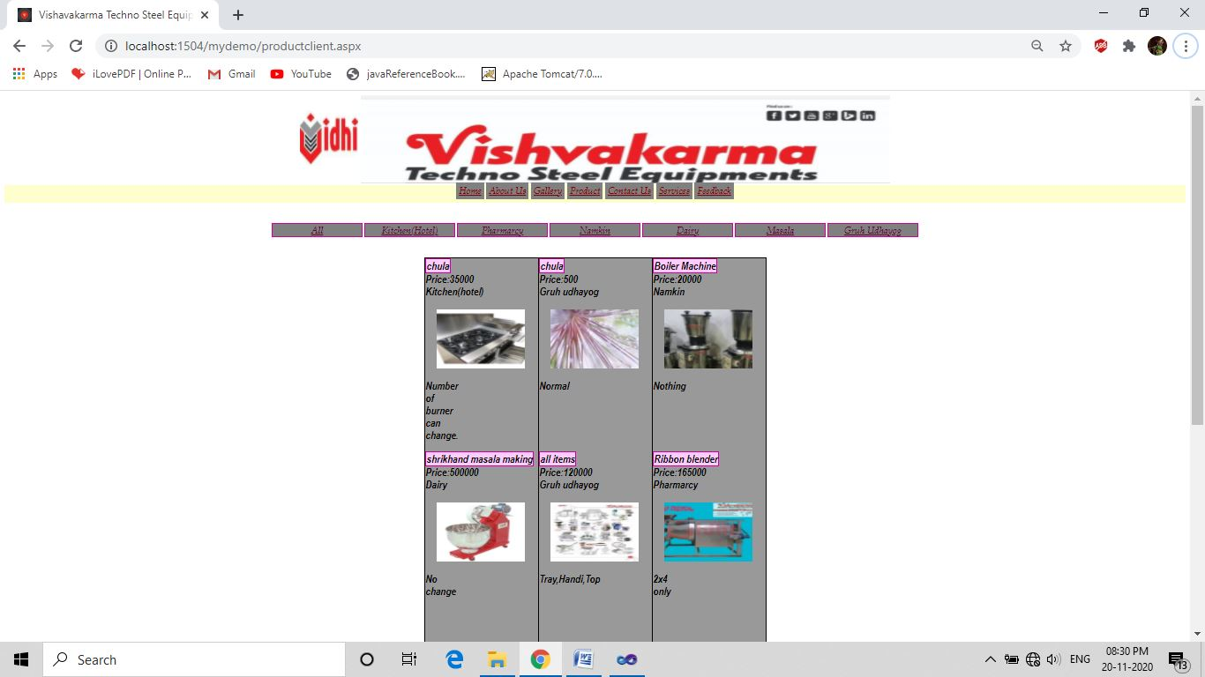

<%@ Page Title="" Language="C#" MasterPageFile="~/MasterPageclient.master" AutoEventWireup="true" CodeFile="productclient.aspx.cs" Inherits="productclient" %>

<asp:Content ID="Content1" ContentPlaceHolderID="head" Runat="Server">

<style>

.zoom

{ transition: transform .2s;

padding: 20px;

}

.zoom:hover

{ transform:scale(1.6); }

.link

{ background-color:#9999FF;

border: solid;

margin:2px ,2px,2px,2px;

font-family:Book Antiqua;

font-style:italic;

font-weight:lighter;

text-transform:capitalize;

text-align:center;

}

.link:hover

{ background-color: transparent ;

text-transform: uppercase;

color: Blue;

}

.link:visited

{ background-color:transparent;

text-transform: uppercase;

color: Maroon;

}

.link:active

{ background-color: transparent ;

text-transform: uppercase;

color: Green ;

}

</style>

</asp:Content>

<asp:Content ID="Content2" ContentPlaceHolderID="ContentPlaceHolder1" Runat="Server">

<div><br /><br />

<table>

<tr> <td>

<asp:LinkButton ID="LinkAll" runat="server" Height="20px" Width="150px" ForeColor="#660033" BorderColor="#CC0099"

BorderStyle="Solid" BorderWidth="2px" onclick="LinkAll_Click" CssClass="link"

>All</asp:LinkButton>

</td> <td>

<asp:LinkButton ID="linkKitchen" runat="server" Height="20px" Width="150px" ForeColor="#660033" BorderColor="#CC0099" BorderStyle="Solid" BorderWidth="2px" onclick="linkKitchen_Click" CssClass="link">Kitchen(hotel)</asp:LinkButton>

</td>

<td>

<asp:LinkButton ID="linkPharmarcy" runat="server" Height="20px" Width="150px" ForeColor="#660033" CssClass="link" BorderColor="#CC0099" BorderStyle="Solid" BorderWidth="2px" onclick="linkPharmarcy_Click">Pharmarcy</asp:LinkButton>

</td>

<td>

<asp:LinkButton ID="linkNamkin" runat="server" Height="20px" Width="150px" ForeColor="#660033" CssClass="link" BorderColor="#CC0099" BorderStyle="Solid" BorderWidth="2px" onclick="linkNamkin_Click">Namkin</asp:LinkButton>

</td>

<td>

<asp:LinkButton ID="linkDairy" runat="server" ForeColor="#660033" CssClass="link"

BorderColor="#CC0099" BorderStyle="Solid" BorderWidth="2px"

onclick="linkDairy_Click" Height="20px" Width="150px">Dairy</asp:LinkButton>

</td>

<td>

<asp:LinkButton ID="linkMasala" runat="server" Height="20px" Width="150px" ForeColor="#660033" CssClass="link" BorderColor="#CC0099" BorderStyle="Solid" BorderWidth="2px" onclick="linkMasala_Click">Masala</asp:LinkButton>

</td>

<td>

<asp:LinkButton ID="linkGruh" runat="server" Height="20px" Width="150px" ForeColor="#660033" CssClass="link" BorderColor="#CC0099" BorderStyle="Solid" BorderWidth="2px" onclick="linkGruh_Click">Gruh udhayog</asp:LinkButton>

</td>

</tr>

</table> <br /> <br />

<asp:DataList ID="DataList2" runat="server" DataSourceID="SqlDataSource2"

GridLines="Vertical" RepeatColumns="3" BackColor="#999999"

BorderColor="Black" BorderWidth="2px" BorderStyle="Solid" CellPadding="1"

CellSpacing="1" DataKeyField="P_cat" Font-Bold="True" Font-Italic="True"

Font-Names="Arial Narrow" Font-Size="Large" ForeColor="Black">

<EditItemStyle BackColor="#999999" BorderColor="Black" BorderStyle="Solid"

BorderWidth="2px" HorizontalAlign="Center" VerticalAlign="Middle"

Width="150px" />

<ItemTemplate>

<asp:Label ID="P_NameLabel" runat="server" Text='<%# Eval("P_Name") %>' BackColor="#FFCCFF" BorderColor="#CC0099" BorderStyle="Solid" BorderWidth="2px" />

<br />

<asp:Label ID="P_priceLabel" runat="server" Text='<%# "Price:"+Eval("P_price") %>' />

<br />

<asp:Label ID="P_catLabel" runat="server" Text='<%# Eval("P_cat") %>' />

<br />

<asp:Image ID="Image1" runat="server" ImageUrl='<%# "~/images/product/"+Eval("P_img") %>' Height="100px" Width="150px" CssClass="zoom" />

<br />

<asp:Label ID="P_desLabel" runat="server" Text='<%# Eval("P_des") %>' Height="100px" Width="50px" />

<br />

<br />

</ItemTemplate>

</asp:DataList>

<asp:SqlDataSource ID="SqlDataSource2" runat="server"

ConnectionString="<%$ ConnectionStrings:ConnectionString %>"

SelectCommand="SELECT [P_Name], [P_price], [P_cat], [P_img], [P_des] FROM [T_Product]">

</asp:SqlDataSource>

<asp:SqlDataSource ID="SqlDataSource3" runat="server"

ConnectionString="<%$ ConnectionStrings:ConnectionString %>"

SelectCommand="SELECT * FROM [T_Product] WHERE ([P_cat] = @P_cat)">

<SelectParameters>

<asp:QueryStringParameter Name="P_cat" QueryStringField="category"

Type="String" />

</SelectParameters>

</asp:SqlDataSource>

</div>

</asp:Content>

* **productclient.aspx.cs**

using System;

using System.Collections.Generic;

using System.Linq;

using System.Web;

using System.Web.UI;

using System.Web.UI.WebControls;

public partial class productclient : System.Web.UI.Page

{ protected void Page_Load(object sender, EventArgs e)

{

if(Request.QueryString["category"]!=null)

{

DataList2.DataSourceID = null;

DataList2.DataSource = SqlDataSource3;

DataList2.DataBind();

}

}

protected void LinkAll_Click(object sender, EventArgs e)

{

DataList2.DataSourceID = null;

DataList2.DataSource = SqlDataSource3;

DataList2.DataBind();

Response.Redirect("productclient.aspx");

}

protected void linkKitchen_Click(object sender, EventArgs e)

{

Response.Redirect("productclient.aspx?category=Kitchen(hotel)");

}

protected void linkPharmarcy_Click(object sender, EventArgs e)

{

Response.Redirect("productclient.aspx?category=Pharmarcy");

}

protected void linkNamkin_Click(object sender, EventArgs e)

{ Response.Redirect("productclient.aspx?category=Namkin");

}

protected void linkDairy_Click(object sender, EventArgs e)

{ Response.Redirect("productclient.aspx?category=Dairy");

}

protected void linkMasala_Click(object sender, EventArgs e)

{ Response.Redirect("productclient.aspx?category=Masala");

}

protected void linkGruh_Click(object sender, EventArgs e)

{ Response.Redirect("productclient.aspx?category=Gruh udhayog");

}

}

* **contactusclient.aspx**

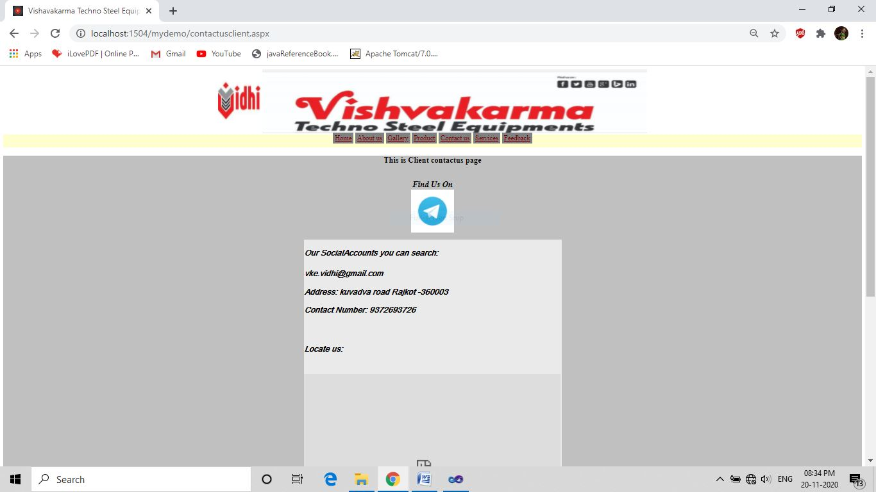

<%@ Page Title="" Language="C#" MasterPageFile="~/MasterPageclient.master" AutoEventWireup="true" CodeFile="contactusclient.aspx.cs" Inherits="contactusclient" %>

<asp:Content ID="Content1" ContentPlaceHolderID="head" Runat="Server">

<style>

.mydiv

{ border: 5px outside Blue;

border-color: Blue;

background-color:Silver;

background-image:url("../images/BACKGROUND IMAGE.jpg");

background-position:center;

background-repeat:no-repeat;

background-size:cover;

}

</style>

</asp:Content>

<asp:Content ID="Content2" ContentPlaceHolderID="ContentPlaceHolder1" Runat="Server">

<div class="mydiv">

<asp:SqlDataSource ID="SqlDataSource1" runat="server"

ConnectionString="<%$ ConnectionStrings:ConnectionString %>"

SelectCommand="SELECT * FROM [T_Contactus]">

</asp:SqlDataSource>

<center>

<h3>This is Client contactus page</h3><br />

<asp:Label ID="lblfindus" runat="server" Text="Find Us On" Font-Bold="True"

Font-Italic="True" Font-Size="Larger"></asp:Label>

<asp:ScriptManager ID="ScriptManager1" runat="server">

</asp:ScriptManager>

<asp:UpdatePanel ID="updateimg" runat="server">

<ContentTemplate>

<asp:Timer ID="Timer1" runat="server" Interval="2000" ontick="Timer1_Tick">

</asp:Timer>

<asp:Image ID="imgchang" runat="server" ImageUrl="~/images/contactus/13.jpg"

Height="100px" Width="100px" />

</ContentTemplate>

</asp:UpdatePanel>

<br />

<asp:DataList ID="DataList1" runat="server" DataSourceID="SqlDataSource1"

Font-Italic="True" Font-Names="Arial Unicode MS" Height="300px"

Width="500px" BackColor="#EAEAEA" >

<ItemTemplate>

<h3>

Our SocialAccounts you can search:<br /><br />

<asp:Label ID="cu_emailLabel" runat="server" Text='<%# Eval("cu_email") %>' />

<br />

<h3> Address:

<asp:Label ID="cu_addLabel" runat="server" Text='<%# Eval("cu_add") %>' />

<br />

<h3>Contact Number:

<asp:Label ID="cu_MoNoLabel" runat="server" Text='<%# Eval("cu_MoNo") %>' />

<br /> <br /> <br />

<h3>Locate us: <br />

<br /> <br />

<iframe src="https://www.google.com/maps/embed?pb=!1m18!1m12!1m3!1d3690.670701610863!2d70.8546578142691!3d22.32829034752226!2m3!1f0!2f0!3f0!3m2!1i1024!2i768!4f13.1!3m3!1m2!1s0x3959b661a0439193%3A0x191351bcdcfbeb98!2sVishvakarma%20Techno%20Steel%20Equipments!5e0!3m2!1sen!2sin!4v1605726798238!5m2!1sen!2sin" width="600" height="450" frameborder="0" style="border:0;" allowfullscreen="" aria-hidden="false" tabindex="0"></iframe>

<br /> <br /> <br />

<asp:Label ID="cu_desLabel" runat="server" Text='<%# Eval("cu_des") %>' />

<br /> <br />

</ItemTemplate>

</asp:DataList>

</center>

</div>

</asp:Content>

* **contactusclient.aspx.cs**

using System;

using System.Collections.Generic;

using System.Linq;

using System.Web;

using System.Web.UI;

using System.Web.UI.WebControls;

public partial class contactusclient : System.Web.UI.Page

{ protected void Page_Load(object sender, EventArgs e)

{

}

protected void Timer1_Tick(object sender, EventArgs e)

{

Random rand = new Random();

int i= rand.Next(1, 13);

imgchang.ImageUrl = "~/images/contactus/" + i.ToString() + ".jpg";

}

}

* **servicesclient.aspx**

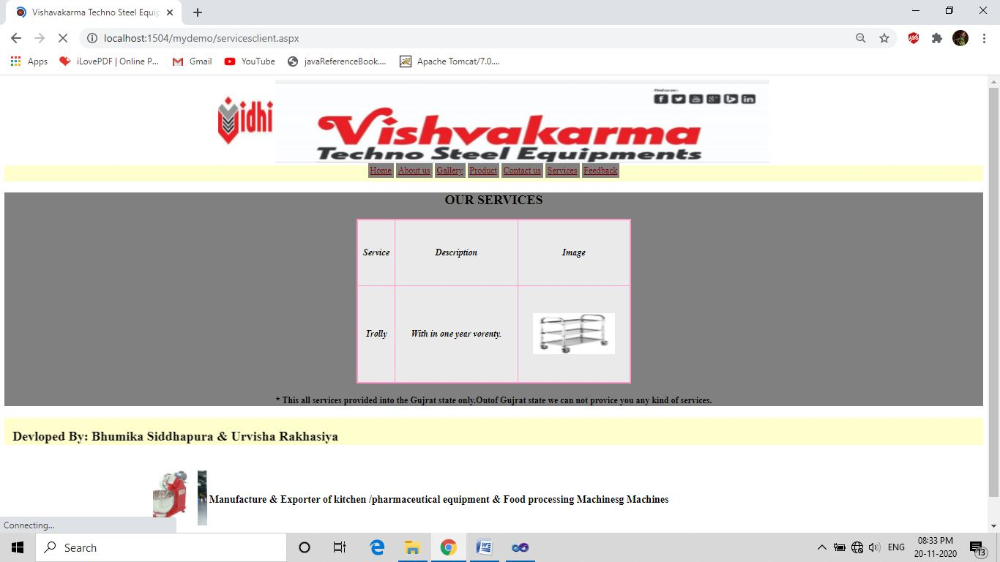

<%@ Page Title="" Language="C#" MasterPageFile="~/MasterPageclient.master" AutoEventWireup="true" CodeFile="servicesclient.aspx.cs" Inherits="servicesclient" %>

<asp:Content ID="Content1" ContentPlaceHolderID="head" Runat="Server">

<style type="text/css">

.style1

{ width: 61px; }

.mydiv

{ border: 5px outside Blue;

border-color: Blue;

text-align:center;

background-color:Gray;

background-image:url("../images/BACKGROUND IMAGE.jpg");

background-position:center;

background-repeat:no-repeat;

background-size:cover;

}

.table

{ background-color: Silver; }

</style>

</asp:Content>

<asp:Content ID="Content2" ContentPlaceHolderID="ContentPlaceHolder1" Runat="Server">

<center>

<div class="mydiv">

<center>

<h2 align="center"> OUR SERVICES</h2>

<asp:SqlDataSource ID="SqlDataSource1" runat="server"

ConnectionString="<%$ ConnectionStrings:ConnectionString %>"

SelectCommand="SELECT [ser_Name], [ser_des], [ser_img] FROM [T_services]"></asp:SqlDataSource>

<asp:GridView ID="GridView1" runat="server" AutoGenerateColumns="False"

DataSourceID="SqlDataSource1" BorderColor="#FF99CC" BorderWidth="3px"

CssClass="mydiv" Font-Bold="True" Font-Italic="True" ForeColor="Black" Height="300px"

Width="500px" BackColor="#EAEAEA"

ShowHeaderWhenEmpty="True" >

<Columns>

<asp:BoundField DataField="ser_Name" HeaderText="Service"

SortExpression="ser_Name" />

<asp:BoundField DataField="ser_des" HeaderText="Description"

SortExpression="ser_des" />

<asp:TemplateField HeaderText="Image">

<ItemTemplate>

<asp:Image ID="Image1" runat="server" ImageUrl='<%# "~/images/"+Eval("ser_img") %>' Height="75px" Width="150px" />

</ItemTemplate>

</asp:TemplateField>

</Columns>

<FooterStyle BorderStyle="Solid" />

</asp:GridView>

<h4 align="center"> * This all services provided into the Gujrat state only.Outof Gujrat state we can not provice you any kind of services.

</h4>

</center>

</div>

</center>

</asp:Content>

* **servicesclient.aspx.cs**

using System;

using System.Collections.Generic;

using System.Linq;

using System.Web;

using System.Web.UI;

using System.Web.UI.WebControls;

public partial class servicesclient : System.Web.UI.Page

{ protected void Page_Load(object sender, EventArgs e)

{

}

}

* **feedbackclient.aspx**

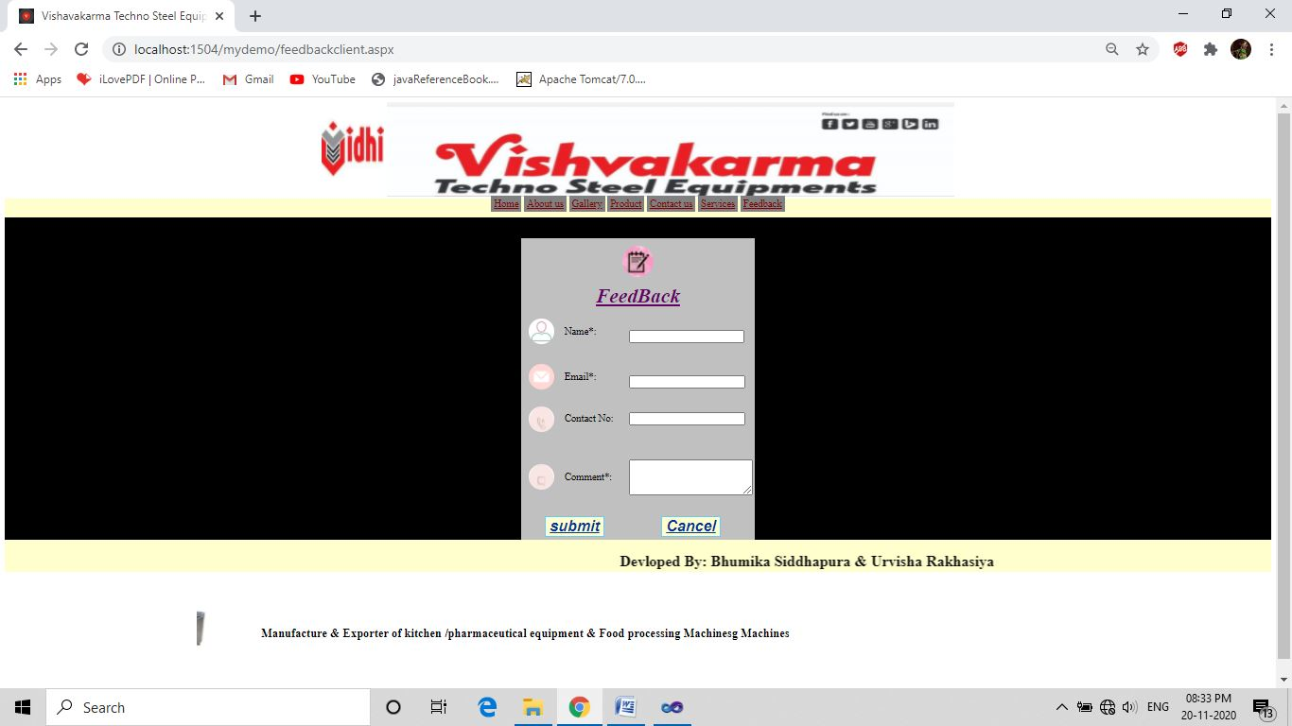

<%@ Page Title="" Language="C#" MasterPageFile="~/MasterPageclient.master" AutoEventWireup="true" CodeFile="feedbackclient.aspx.cs" Inherits="feedbackclient" %>

<asp:Content ID="Content1" ContentPlaceHolderID="head" Runat="Server">

<style>

.zoom

{ transition: transform .2s;

padding: 10px;

border-radius: 50%;

}

.zoom:hover

{ transform:scale(1.6);

}

.mydiv

{ border: 5px outside Blue;

border-color: Blue;

text-align:center;

background-color:Black;

background-image:url("../images/AATA MAKER.jpg");

background-repeat:no-repeat;

background-size:cover;

}.

td

{ width: 100px; }

</style>

</asp:Content>

<asp:Content ID="Content2" ContentPlaceHolderID="ContentPlaceHolder1" Runat="Server">

<div class="mydiv">

<center>

<table style="background-color: Silver;">

<tr >

<td colspan="3" align="center" >

<asp:Image ID="imgadmin" runat="server" ImageUrl="~/images/feedbackmainicon.jpg" ImageAlign="Middle" CssClass="zoom" Height="50px" Width="50px" />

</td> </tr> <br />

<tr >

<td colspan="3" align="center">

<asp:Label ID="btntitle" runat="server" Font-Bold="True" Font-Italic="True"

Font-Overline="False" Font-Underline="True" ForeColor="#660066"

Text="FeedBack" Font-Size="XX-Large" />

</td> </tr>

<tr> <td>

<asp:Image ID="imgnm" runat="server"

ImageUrl="~/images/ADMIN.jpg" Height="40px"

Width="40px" CssClass="zoom"/>

</td>

<td class="td">

<asp:Label ID="lblnm" runat="server" Text="Name*:" EnableViewState="False" ></asp:Label>

</td>

<td class="td">

<br />

<br />

<asp:TextBox ID="txtnm" runat="server" Width="175px" ></asp:TextBox>

<br />

<asp:RequiredFieldValidator ID="RequiredFieldValidator1" runat="server"

ControlToValidate="txtnm" ErrorMessage="Must Enter Your Name" Font-Bold="True"

Font-Italic="True" ForeColor="Red"></asp:RequiredFieldValidator>

</td>

</tr>

<tr>

<td>

<asp:Image ID="imgcntno" runat="server" ImageUrl="~/images/EMAIL.jpg" Height="40px" Width="40px" CssClass="zoom" />

</td>

<td class="td">

<asp:Label ID="lblcntno" runat="server" Text="Email*:" ></asp:Label>

</td>

<td class="td">

<br />

<br />

<asp:TextBox ID="txtemail" runat="server" Width="177px"></asp:TextBox>

<br />

<asp:RequiredFieldValidator ID="RequiredFieldValidator2" runat="server"

ControlToValidate="txtemail" ErrorMessage="Must Enter Email id"

Font-Bold="True" Font-Italic="True" ForeColor="Red"></asp:RequiredFieldValidator>

<br />

</td>

</tr>

<tr>

<td>

<asp:Image ID="imgemail" runat="server" ImageUrl="~/images/PHONE NO.jpg" Height="40px"

Width="40px" CssClass="zoom" />

</td>

<td class="td">

<asp:Label ID="lblemail" runat="server" Text="Contact No:" ></asp:Label>

</td>

<td class="td">

<asp:TextBox ID="txtcntno" runat="server" MaxLength="12" Width="177px"></asp:TextBox>

</td>

</tr>

<tr>

<td>

<asp:Image ID="imgcomment" runat="server" ImageUrl="~/images/COMMENT.jpg"

Height="40px" Width="40px" CssClass="zoom" />

</td>

<td class="td">

<asp:Label ID="lblcomment" runat="server" Text="Comment*:" ></asp:Label>

</td>

<td class="td">

<asp:RequiredFieldValidator ID="RequiredFieldValidator4" runat="server"

ControlToValidate="txtcomment"

ErrorMessage="Comment Must Required to Add Feedback" Font-Bold="True"

Font-Italic="True" ForeColor="Red"></asp:RequiredFieldValidator>

<br />

<asp:TextBox ID="txtcomment" runat="server" TextMode="MultiLine" Height="49px"

Width="190px"></asp:TextBox>

<br />

<br />

<br />

</td>

</tr> <br /> <tr>

<td colspan="2" align="center">

<asp:Button ID="btnsubmit" runat="server" Text="submit" Font-Italic="True"

Font-Bold="True" Font-Underline="True" ForeColor="#003399"

BorderColor="#66CCFF" BorderStyle="Solid" BackColor="#FFFFCC"

Font-Size="X-Large" onclick="btnsubmit_Click" ></asp:Button>

</td>

<td align="center">

<asp:Button ID="btnclear" runat="server" Text="Cancel" Font-Italic="True"

Font-Bold="True" Font-Underline="True" ForeColor="#003399"

BorderColor="#66CCFF" BorderStyle="Solid" BackColor="#FFFFCC"

Font-Size="X-Large" onclick="btnclear_Click" />

</td>

</tr>

<tr>

<td colspan="3" align="center">

<asp:Label ID="lblmsg" runat="server" Text="" Font-Bold="True"

Font-Italic="True" Font-Size="Larger" Font-Names="Arial" ForeColor="#FF3300"></asp:Label>

</td>

</tr>

</table>

</center>

</div>

</asp:Content>

* **feedbackclient.aspx.cs**

using System;

using System.Collections.Generic;

using System.Linq;

using System.Web;

using System.Web.UI;

using System.Web.UI.WebControls;

using System.Data.SqlClient;

public partial class feedbackclient : System.Web.UI.Page

{ protected void Page_Load(object sender, EventArgs e)

{ }

protected void btnsubmit_Click(object sender, EventArgs e)

{

string constr = "Data Source=.\\SQLEXPRESS;AttachDbFilename=|DataDirectory|\\Databaseproject.mdf;Integrated Security=True;User Instance=True";

SqlConnection con = new SqlConnection(constr);

con.Open();

string str = "insert into T_Feedback (F_name,F_MoNo,F_email,F_comment)values(@F_name,@F_MoNo,@F_email,@F_comment)";

SqlCommand cmd = new SqlCommand(str, con);

cmd.Parameters.AddWithValue("@F_name", txtnm.Text);

cmd.Parameters.AddWithValue("@F_email", txtemail.Text);

cmd.Parameters.AddWithValue("@F_MoNo", txtcntno.Text);

cmd.Parameters.AddWithValue("@F_comment", txtcomment.Text);

int ans2 = cmd.ExecuteNonQuery();

if (ans2 > 0)

{ lblmsg.Text = "Feedback submited...";

Response.Redirect("feedbackclient.aspx");

}

else

{ lblmsg.Text = "problem occur....."; }

}

protected void btnclear_Click(object sender, EventArgs e)

{ txtnm.Text = "";

txtemail.Text = "";

txtcntno.Text = "";

txtcomment.Text = "";

}

}

**Testing Techniques**

* **Black Box Testing**

Black box testing is a software testing techniques in which functionality of the software under test (SUT) is tested without looking at the internal code structure, implementation details and knowledge of internal paths of the software. This type of testing is based entirely on the software requirements and specifications.

Error: invalid entered username or password.

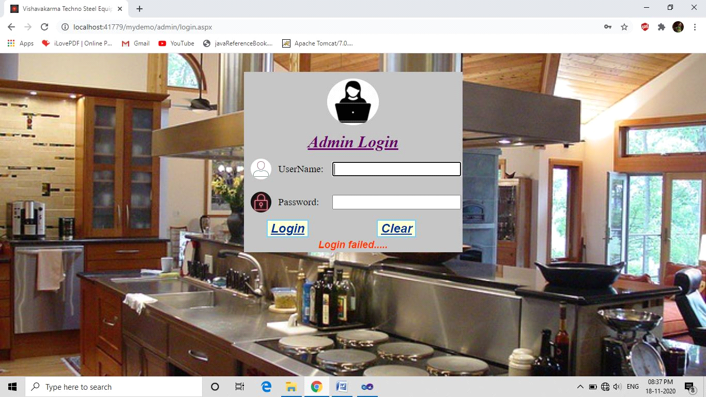

Solution: Enter valid password and username.

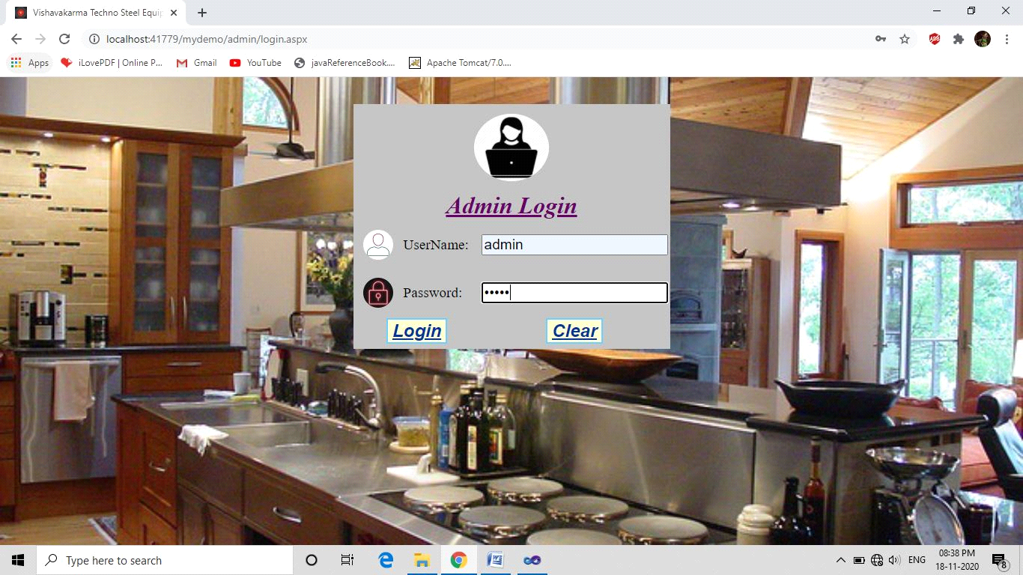

Error: specific formatted file only add.

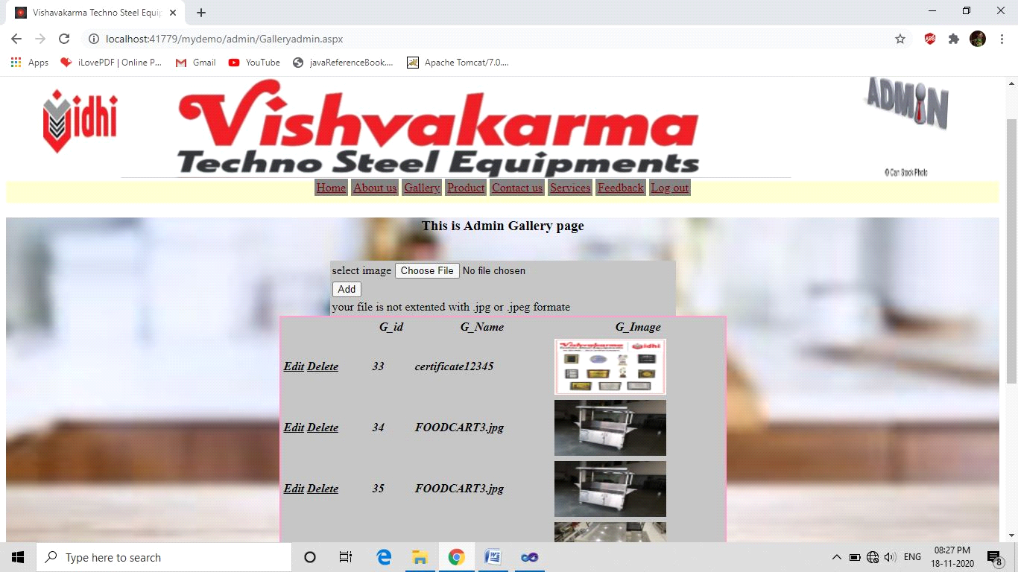

Solution: It will accept only .jpg and .jpeg formatted files

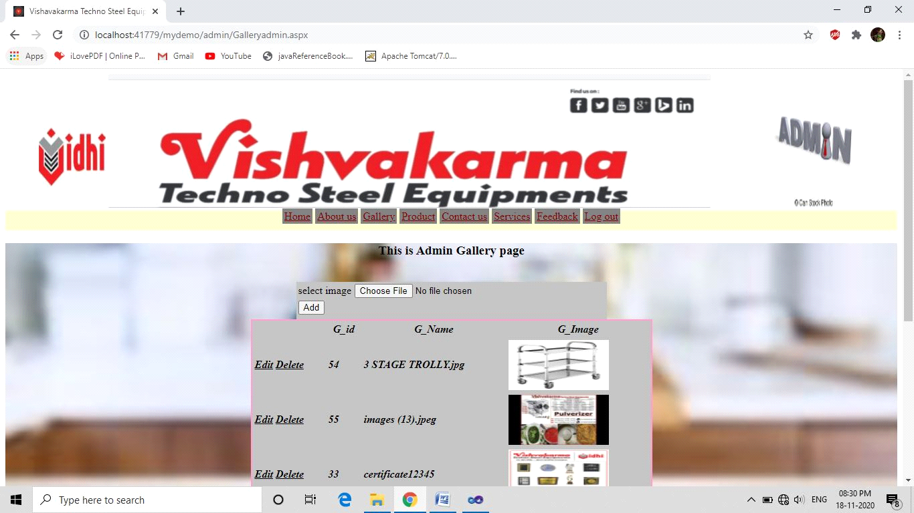

Error: validation is must follow.

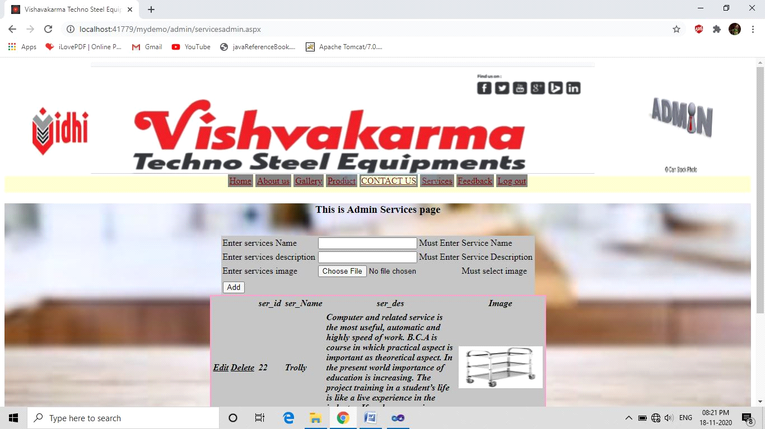

Solution: First enter all fields then add the specific data into database.

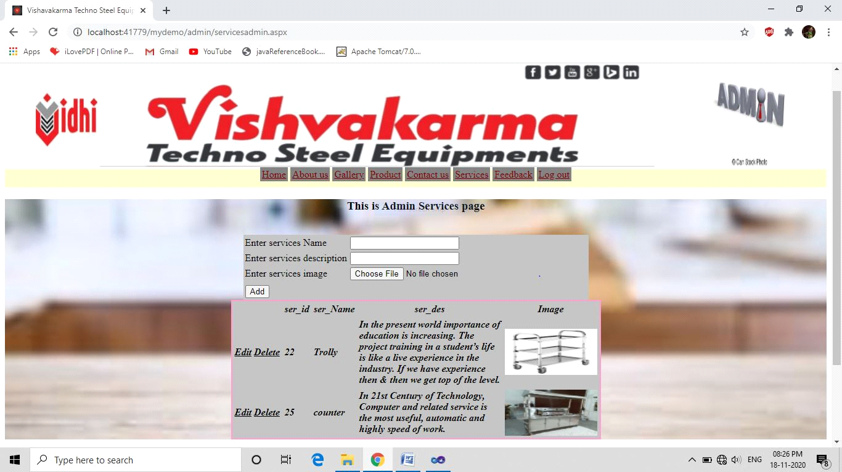

* **White Box Testing**

White box testing is based on an analysis of internal working and structure of a piece of software. White box testing is the process of giving the input to the system and checking how the system processes that input to generate the required output. It is necessary for a tester to have the full knowledge of the source code.

Error: connection string is not match with database connection string.

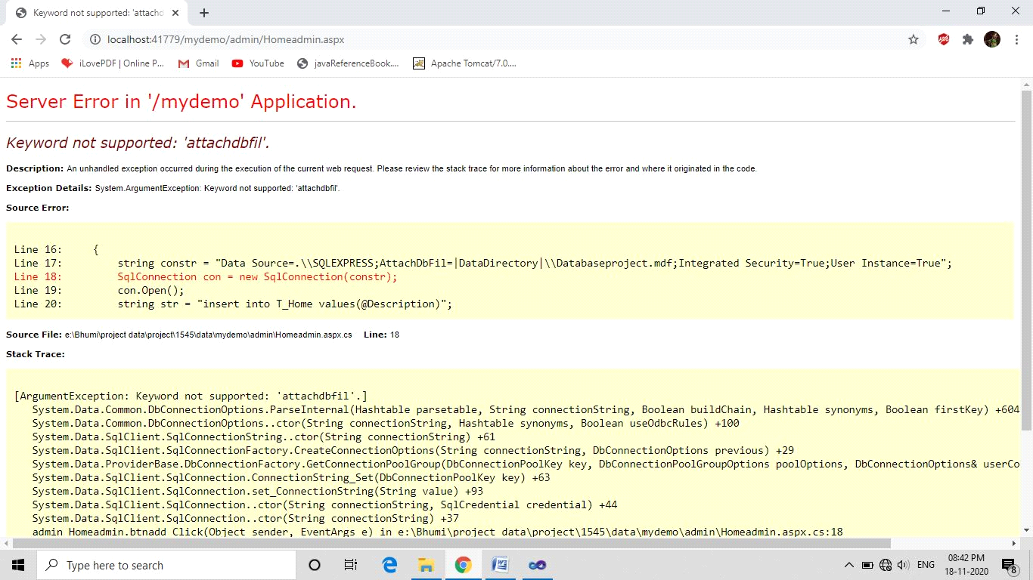

Solution: First match your connection string with database connection string.

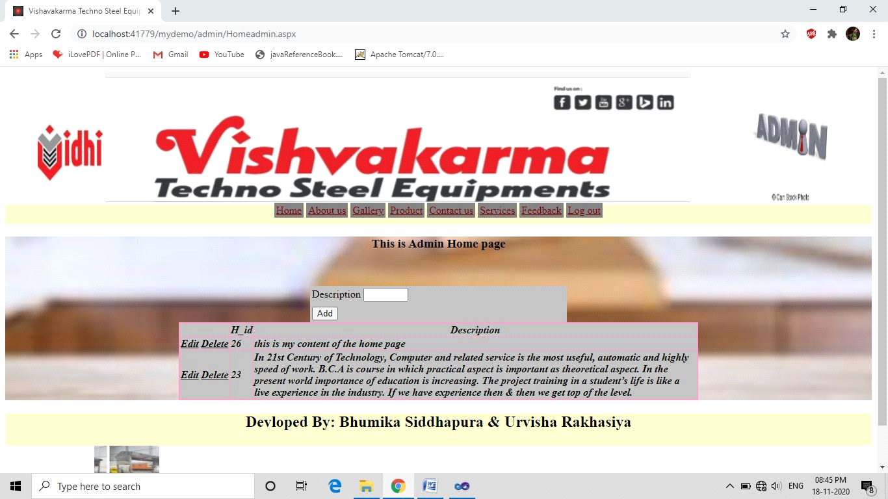

Error: Data key of grid view not filled.

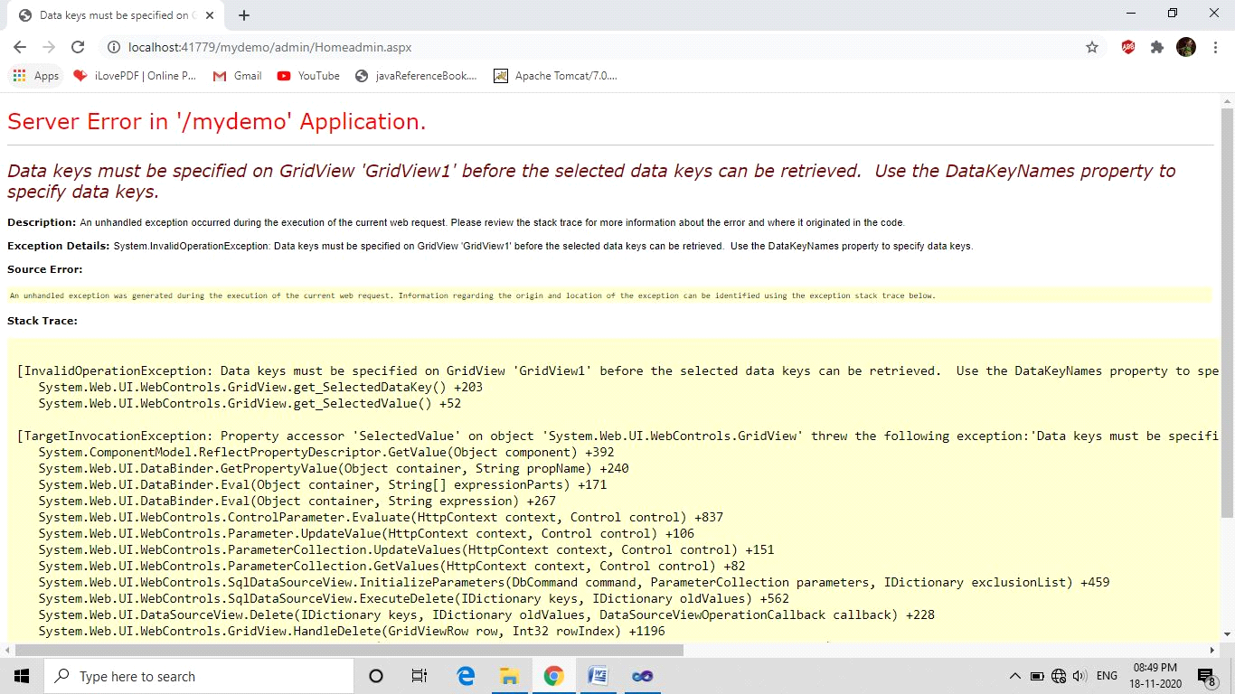

Solution: Fill Data Key of grid view.



Error: Field name is not match with data base field name.

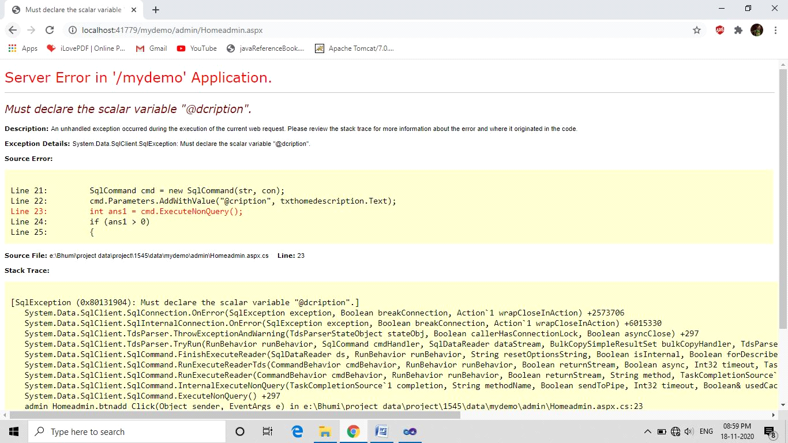

Solution: First check all field name and match that all with the database field name

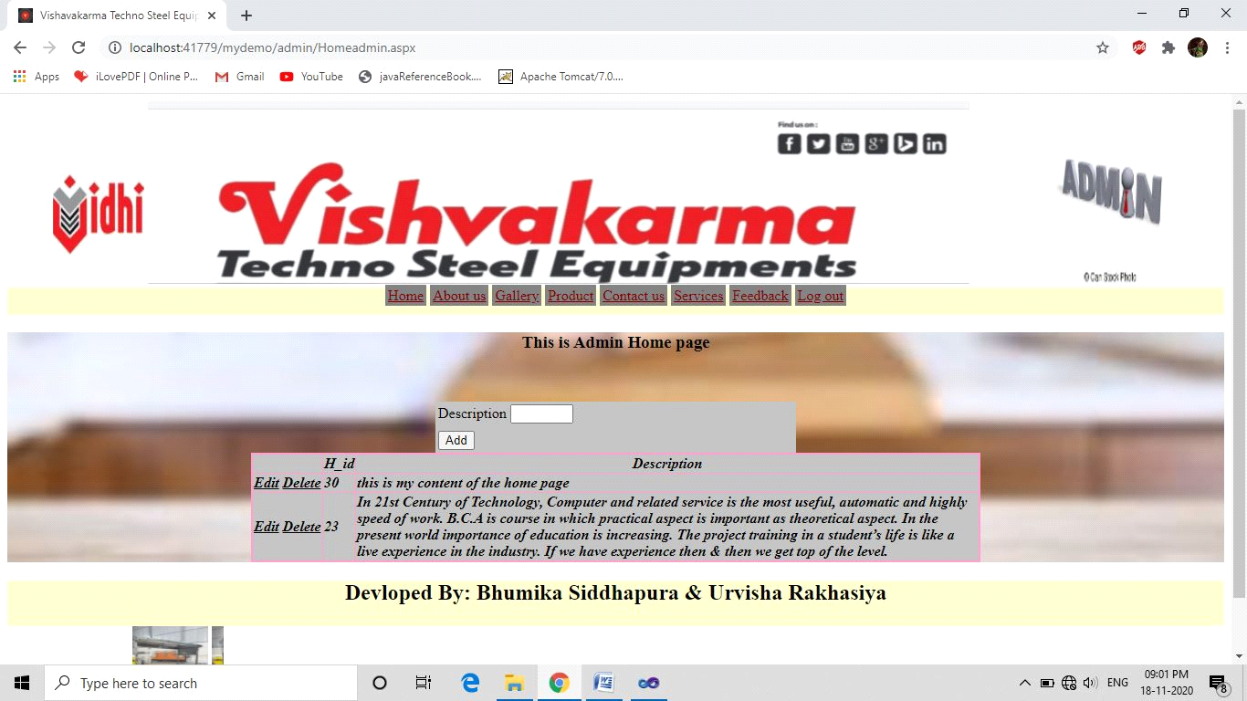

* **Gray Box Testing**

Gray box testing also called gray box analysis is a strategy for software debugging in which the tester has limited knowledge of the internal details of the program. A gray box is a device, program or system whose working is partially understood.

Error: After Logout admin click on back button.

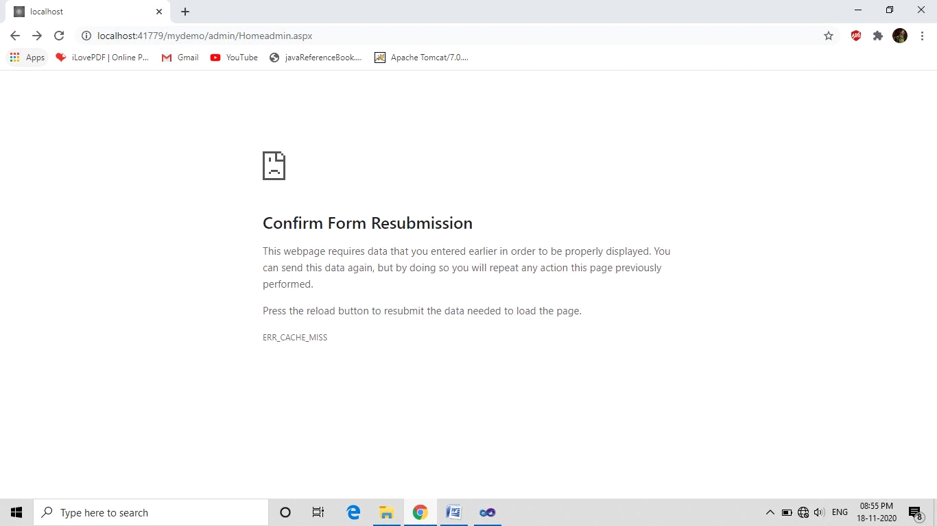

Solution: It cat done because of the session so first need to login in admin.

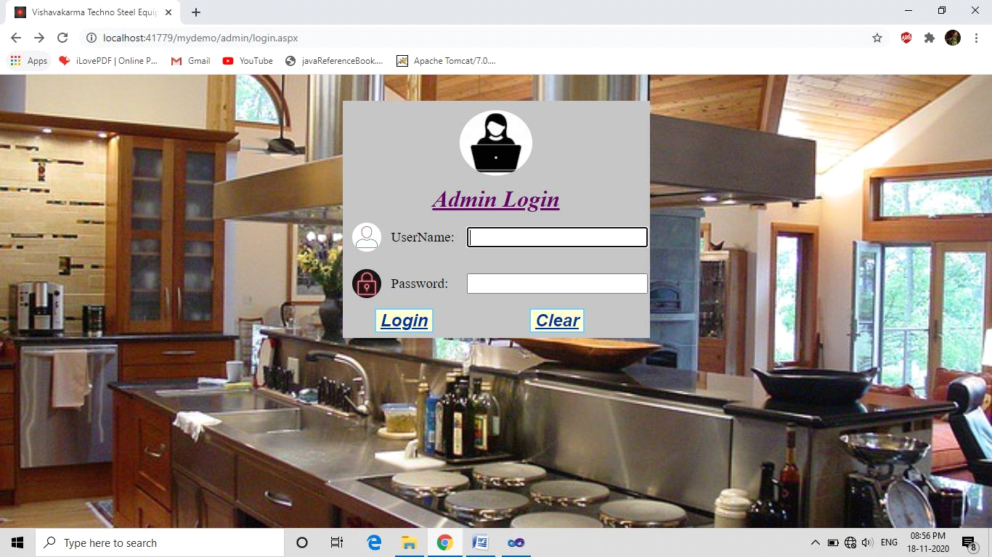

Error: File upload control name is not match.

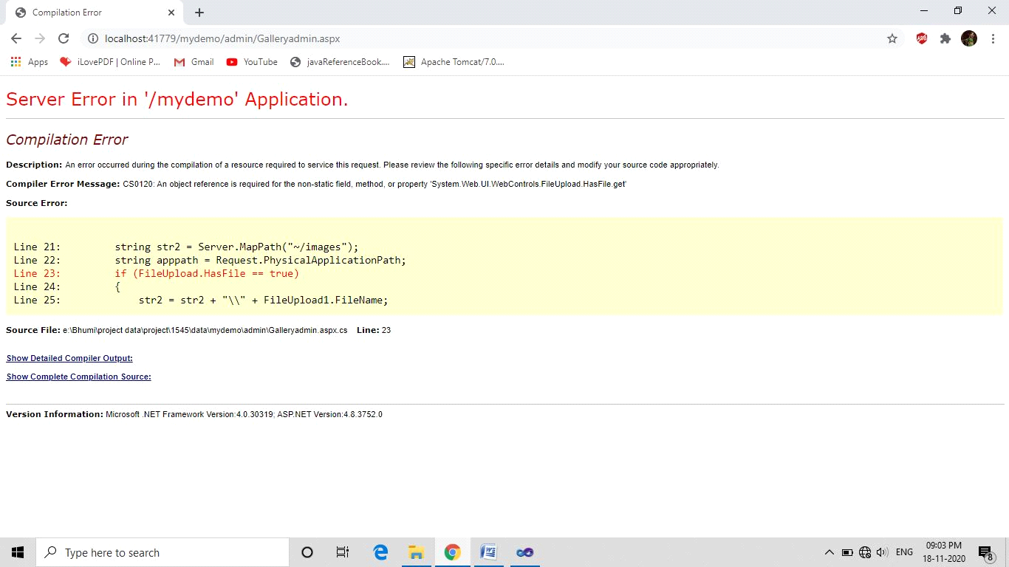

Solution: File upload control id must need to match so first checks this.

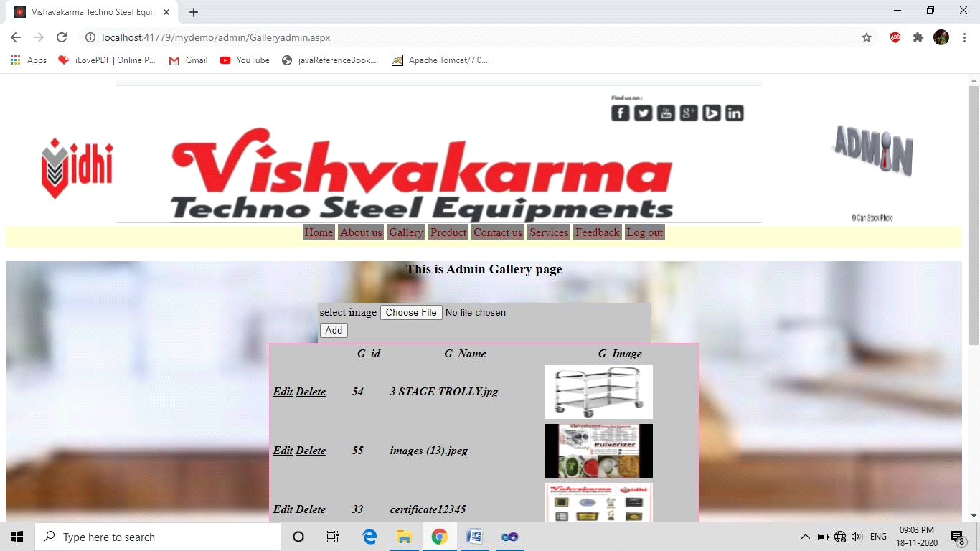

**Future Enhancement**

In future we will provide the facility of online shopping. Billing will be added in our website and we also provide all the information related to the Vishvakarma techno steel equipments. This website will be increasing in that and this is achievement of our website.

Our site can also make popular the products of Vishvakarma techno steel equipments.

**Bibliography**

[**www.w3school.com**](http://www.w3school.com/) **write page list**

We use from this site some effects demo and dome animation code.

[**www.youtube.com**](http://www.youtube.com) **write url of videos**

We use this website to solve some error and other some tutorials for effects.

[**www.vke-vidhi.com**](http://www.vke-vidhi.com/)

Using this site we download some images of products and broachers.

[**www.pinterest.com**](http://www.pinterest.com/)

We use this for dome images of machines and background.